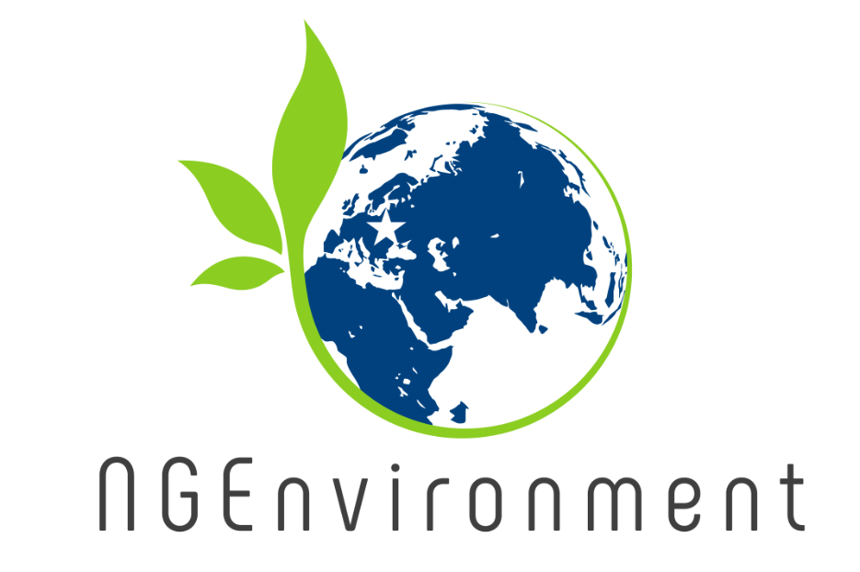

NGEnvironment
Foster European Active Citizenship and Sustainability
Through Ecological Thinking by NGOs

Valorisation Plan

Project Title NGEnvironment
Foster European Active Citizenship and Sustainability
Through Ecological Thinking by NGOs

Project Acronym NGEnvironment

Reference Number 2018-1-DE02-KA204-005014

Content

Introduction 3
Working definition 4
Strategy 5
Step 1 - Defining the Community, target group and interested people of the project 5
Step 2 - Identifying appropriate communication channels 6
Step 3 - To assure a broader dissemination strategy 9
Step 4 – Promotion aids 10
ANNEX I: YES-Dissemination-Report

Introduction
All partners are aware of the relevance of a high quality and outreaching dissemination and they are interested in implementing a project that has a long-lasting and sustainable impact. Furthermore, dissemination and exploitation activities are crucial to maintain a transfer of project results and good practices, enhance the impact and visibility of the Erasmus+ programme and to feed policy-processes.
In order to achieve these goals and getting a big target-group interested and engaged into the project, dissemination activities will find a high priority during the whole project duration and after the project as well. Due to the different phases of the project the intensity and kind of dissemination will vary, but nevertheless, all project partners will engage in dissemination activities throughout the project to keep all internationally interested parties informed about the project´s progress and outcomes.
Therefore, the project ‘NGEnvironment’ puts emphasis on offering a constant dissemination and exploitation strategy not only during the whole project duration but afterwards as well. Hence, for such a strategy all project partners need to know who to address and to know the target group, and the reason why they are addressing them.
The results of the Erasmus+ funded project YES need to achieve maximum impact and what is more a wide audience as well as future policies need to be informed.
This means that all dissemination and exploitation activities within the Erasmus+ funded project NGEnvironment are key to safeguard impact and sustainability. For this purpose, this Valorisation Plan was developed. It is to be understood as a strategic framework that outlines a clear plan to carry out successful dissemination, and to ensure an effective exploitation of the project´s outcomes.
The partners plan to carry out a variety of activities and they set benchmarks they need to achieve. Thus, following, we will describe these benchmarks and we will outline the strategies and activities that will help us to achieve them. A Dissemination Reporting Table (ANNEX I), which will be provided also as an additional document, will be filled out on a regular basis by all project partners.

Working definition
Following, we will establish a working definition for this valorisation plan by explaining the meaning of valorisation, dissemination and exploitation for this purpose:
Valorisation for this purpose means to combine the testing, dissemination and exploitation of the YES project results and their development. It encompasses the sustainable application of these results over time in formal and informal systems, in the practices of companies and associations as well as in the personal training goals of every individual. Valorisation aims for improvement of the return on public and private investments in the area of training and education in addition to fostering innovation in education and training systems.
Dissemination for this purpose means to spread information. Well planned dissemination entails providing information on the quality, relevance, and effectiveness of project results to key parties and target groups. It is crucial that dissemination starts with the beginning of a project and should not end with the successful ending of it. Therefore, a dissemination strategy should be managed throughout the lifecycle of a project. The aim of this dissemination strategy is to raise the awareness of the addressed target group and evolve a process of promotion. A well applied dissemination strategy will help stakeholders to understand the applied methodology and encourages them to validate the products and assume a sense of ownership with the YES project outputs.
Mainstreaming and multiplication of project outputs are activities for the exploitation of a project. It entails the transferring of results of projects to appropriate policy and decision-makers and the planned process of convincing individual end-users and institutional end-users to adopt and/or apply the results of the project. The difference to dissemination is that exploitation is usually confined to that period when initial development work has been completed and prototypes of products or services are available. Exploitation and dissemination activities are closely related and therefore the different activities and strategies will overlap often.
Anyway, the focus of the dissemination strategy and activities is to spread the idea behind the project and its results over the whole project duration and to get in contact with stakeholders. These activities will intensify as the project progresses, as we have first results then.

Strategy

Step 1 - Defining the Community, target group and interested people of the project
It is of greatest importance to have a clear image of the project’s target group. Otherwise, it is not possible to evaluate the quality and effectiveness of the dissemination activities. To safeguard that all partners have the same understanding of the project´s dissemination objectives, the target group will be defined in the following. As the project runs through different phases, we will re-assess and –formulate the objectives if necessary. Therefore, it is also relevant to ensure to be aware of the target group’s needs.
In the project, we need to address following target groups:
- YOUNG LEARNERS/YOUTH GROUPS: Here, we address the youth of Europe that use the YES tool for learning purposes. Here, the activities should not only reach a large audience but they should also reduce reluctance towards modern technology.
- YOUTH EDUCATORS/YOUTH WORKERS: Youth Workers, trainers or teachers are the main facilitators. Once they are convinced of the system, they can help to implement the tool by using and recommending it to others.
- INSTITUTIONS/ORGANISATIONS: There will be an increased capacity and professionalism to work at EU/international level.
- FAMILY: Here, we address the families to raise awareness of the prospects of learning with new media and innovative serious game designs in non-formal learning.
- COMMUNITY: We aim to address the European community as well, because it is one of our aims to raise the awareness for learning related issues for

Step 2 - Identifying appropriate communication channels
In NGEnvironment we have to deal with at least five different target groups, and all of them need to be contacted through different communication channels. We will focus on communication tools and channels such like posters, leaflets, brochures, online newsletters, online press releases, and pages in social networks as well as personal contacts and classic (print-) media and papers.

Step 3 - To assure a broader dissemination strategy
Considering a broader dissemination strategy to lay the foundations for later publications and events, it is inevitable to start with dissemination activities early in the project, even if they take place on a more general layer. To ensure later activities to be successful. Beginning with the dissemination at an early stage is important due to following reasons.
- Awareness is easily raised by providing information about the project and the outcomes, even if they might be vague. And such awareness might be the most important aspect for sustainability.
- The aims and objectives of the YES project can be outlined anyway.
- We will provide constant information to the different stakeholders from the beginning of the project, which enables them to follow and understand all processes of the YES project even better.
- To foster exchange, we can build relationships to other organisation that carry out similar activities.

Step 4 – Promotion aids
Please find below the dissemination channels the NGEnvironment consortium wants to focus on:

Project Branding Strategy:
We will brand all Intellectual Outcomes with the following logo:

Furthermore, this logo will be used in all necessary templates which are created immediately after the project beginning. Due to its versatility the branding concept will be facilitated in the full range of paper-based and online environments.
Project Website:
To communicate with the public and to keep them up to date with the latest information and outcomes, we created a website that acts as a central communication instrument:
The projects website http://ngenvironment.eduproject.eu will act as the projects window to the WWW, and it will provide the public with the follow information:
- NGEnvironment project
- Aims and objectives
- YES workshops
- Introduction of project partner
- Links to partner websites
- Contact details

The project website will be available in all partner languages (English, German, Spanish, Romanian, Italian, Portuguese, Maltese), and we will update the information displayed throughout the project lifecycle.
Furthermore, on this website, all Intellectual Outputs, supporting documents, and press releases are available. Furthermore, we will inform the public about our meetings and events here.
Online Presentation:
The consortium will present the NGEnvironment project on their own websites and promote the project throughout their organisations.
Press releases:
The consortium will publish newspaper articles, and press releases put articles in scientific journals as well, to raise the awareness of different target groups via different channels all over the EU.
Partners should complete the following database listing contact points for:
- National/Regional newspapers
- Relevant industry/sector magazines/journals
- Relevant sector online publications
- Relevant EU publications

To create a good press release, that raise the awareness of different target groups, a number of key principles have to be considered:

- Good headline
- Answer key question in the first paragraph
- Use of active verbs and simple wordings
- Use of simple sentences

Online Newsletter:
We will use both internal newsletters of the different partner organisations, and newsletters circulated by the consortium to keep the interested public and stakeholders informed about the project status. The newsletters follow an agreed design that is in line with the branding strategy. All project-related newsletters will be created in Norwegian, German, Italian and English. The internal newsletters are published in whatever language the organisation decides.

Promotional Flyer/Posters:
The consortium will develop flyers/posters in all partner languages as well as English. The consortium will create flyers/posters to raise the awareness of international multipliers and therefor will be presented in various contexts.
Presentation at Conference:
The consortium will promote the YES project at conferences, workshops or the like to raise awareness.
Social networks:
The topic general project presentation is to collect all presentations (separated the fair presentations) the partners give during the lifetime of the project.
All dissemination and exploitation activities will be documented by the individual partners throughout the project.

ANNEX I :
NGEnvironment-Dissemination-Report

NGEnvironment-Dissemination-Report
2018-1-DE02-KA204-005014
Project Partner

PARTNER: | REPORTING PERIOD:

ONLINE

Published info/news on project’s websites
No. | ACTION: | DATE: | GOAL: | OUTCOMES: | TARGET GROUP(S): | NUMBERS REACHED: | PROVE OF ACTIVITY (DOCUMENT, SREENSHOT, LINK TO ACTIVITY, PICTURES ETC.):
Established links to the NGEnvironment website from other sites
No. | ACTION: | DATE: | GOAL: | OUTCOMES: | TARGET GROUP(S): | NUMBERS REACHED: | PROVE OF ACTIVITY (DOCUMENT, SREENSHOT, LINK TO ACTIVITY, PICTURES ETC.):
Distributed digital newsletters, announcements and info via e-mail
No. | ACTION: | DATE: | GOAL: | OUTCOMES: | TARGET GROUP(S): | NUMBERS REACHED: | PROVE OF ACTIVITY (DOCUMENT, SREENSHOT, LINK TO ACTIVITY, PICTURES ETC.):
Used online social networks to disseminate info
No. | ACTION: | DATE: | GOAL: | OUTCOMES: | TARGET GROUP(S): | NUMBERS REACHED: | PROVE OF ACTIVITY (DOCUMENT, SREENSHOT, LINK TO ACTIVITY, PICTURES ETC.):
OTHER ONLINE ACTIVITIES
No. | ACTION: | DATE: | GOAL: | OUTCOMES: | TARGET GROUP(S): | NUMBERS REACHED: | PROVE OF ACTIVITY (DOCUMENT, SREENSHOT, LINK TO ACTIVITY, PICTURES ETC.):

PRINT
Distributed printed material and YES products at conferences, meetings etc.
No. | ACTION: | DATE: | GOAL: | OUTCOMES: | TARGET GROUP(S): | NUMBERS REACHED: | PROVE OF ACTIVITY (DOCUMENT, SREENSHOT, LINK TO ACTIVITY, PICTURES ETC.):
Published NGEnvironment info in newsletters, newspapers, magazines, etc.
No. | ACTION: | DATE: | GOAL: | OUTCOMES: | TARGET GROUP(S): | NUMBERS REACHED: | PROVE OF ACTIVITY (DOCUMENT, SREENSHOT, LINK TO ACTIVITY, PICTURES ETC.):
Published articles in local and international journals
No. | ACTION: | DATE: | GOAL: | OUTCOMES: | TARGET GROUP(S): | NUMBERS REACHED: | PROVE OF ACTIVITY (DOCUMENT, SREENSHOT, LINK TO ACTIVITY, PICTURES ETC.):
OTHER PRINT ACTIVITIES
No. | ACTION: | DATE: | GOAL: | OUTCOMES: | TARGET GROUP(S): | NUMBERS REACHED: | PROVE OF ACTIVITY (DOCUMENT, SREENSHOT, LINK TO ACTIVITY, PICTURES ETC.):

FACE-TO-FACE

Training workshops – presentations at conferences - Events
No. | ACTION: | DATE: | GOAL: | OUTCOMES: | TARGET GROUP(S): | NUMBERS REACHED: | PROVE OF ACTIVITY (DOCUMENT, SREENSHOT, LINK TO ACTIVITY, PICTURES ETC.):
OTHER FACE-TO-FACE ACTIVITIES
No. | ACTION: | DATE: | GOAL: | OUTCOMES: | TARGET GROUP(S): | NUMBERS REACHED: | PROVE OF ACTIVITY (DOCUMENT, SREENSHOT, LINK TO ACTIVITY, PICTURES ETC.):

ONLINE PRESENTATIONS & SOCIAL MEDIA

No. | ACTION: | DATE: | GOAL: | OUTCOMES: | TARGET GROUP(S): | NUMBERS REACHED: | PROVE OF ACTIVITY (DOCUMENT, SREENSHOT, LINK TO ACTIVITY, PICTURES ETC.):
OTHER DISSEMINATION ACTIVITIES
No. | ACTION: | DATE: | GOAL: | OUTCOMES: | TARGET GROUP(S): | NUMBERS REACHED: | PROVE OF ACTIVITY (DOCUMENT, SREENSHOT, LINK TO ACTIVITY, PICTURES ETC.):

