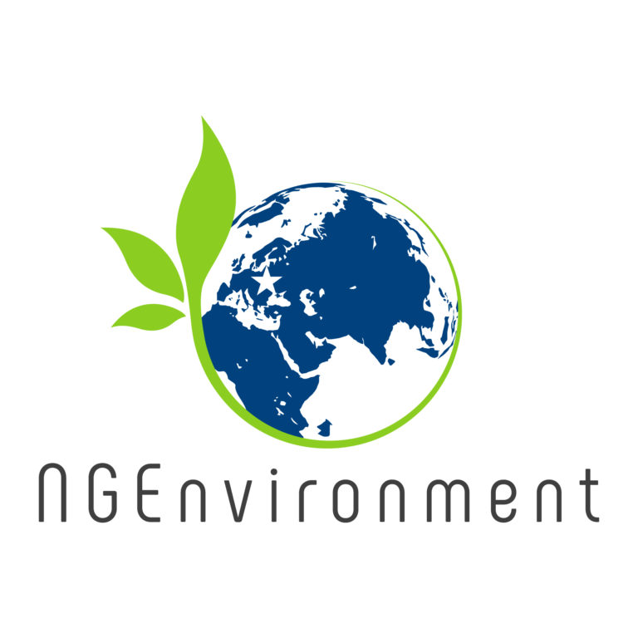
NGEnvironment
Foster European Active Citizenship and Sustainability
Through Ecological Thinking by NGOs
Project Number: 2018-1-DE02-KA204-005014

Agenda for the fifth NGEnvironment Partner Meeting as an Online Meeting
The NGEnvironment Survival Guide and Policy Paper Conference
23rd to 25th of March 2021

Project Title: Foster European Active Citizenship and Sustainability
Through Ecological Thinking by NGOs
Acronym: NGEnvironment
Reference number: 2018-1-DE02-KA204-005014
Project partners: P1 University Paderborn (UPB), DE
P2 Right Challenge (RC), PT
P3 EPEK – Society for Environmental Education of Korinthia (EPEK), GR
P4 Across Limits Ltd. (AL), MT
P5 Future in Perspective (FIPL), IRL
P6 Asociación cultural y medioambiental Permacultura Cantabria (PC), ES
P7 SINERGIE Soc. Cons. a r.l. (SIN), IT
P8 Grupul Pentru Integrare Europeana Romania (GIE), RO
Host: Across Limits Ltd., MT
Venue: Online

Tuesday, 23rd of March 2021 –
Start day
Approx.  Time | Topic | Chair
13.00 – 13.15 | Welcoming the NGEnvironment partners  (Maryrose Francica / Marc Beutner)  - Warm welcome  Schedule of the meeting | AL / UPB
13.15 – 13.30 | Current Status of the NGEnvironment Project in March 2021  (Marc Beutner)  - Current Status of the IOs  - Rationale, purpose, and aims of the project  - Status of the Multiplier Events | UPB
13.30 –  15.0 | Status of the Website and the Learning Environment  (Across Limits Ltd. – AL)  - Current status  - Discussion | AL
15.00 –  15.15 | Short break | All partners
15.15 -  16.00 | Discussion on Video-documentation | UPB/FIPL
16.00 -17.00 | Steps to go - Agreement on Deadlines | UPB

Wednesday, 24th of March 2021 –
Start day
Approx.  Time | Topic | Chair
10.00 – 10.30 | Discussion on the upcomings IOs | UPB
10.30 – 11.00 | Insights into the current situation in Portugal  (Right Challenge - RC) | RC
11.00 – 11.30 | Insights into the current situation in Greece  (Society for Environmental Education of Korinthia - EPEK) | EPEK
11.30 – 12.00 | Insights into the current situation in Malta  (Across Limits Ltd. – AL) | AL
12.00 –  12.30 | Insights into the current situation in Ireland  (Future in Perspective - FIPL) | FIPL
12.00 –  14.00 | Lunch break
14.00 –  14.30 | Insights into the current situation in Germany  (University Paderborn - UPB) | UPB
14.30 – 15.00 | Insights into the current situation in Spain  (Asociación cultural y medioambiental Permacultura Cantabria -PC) | PC
15.00 –  15.30 | Insights into the current situation in Italy  (SINERGIE Soc. Cons. a r.l. - SIN) | SIN
15.30 – 16.00 | Insights into the current situation in Romania  (Grupul Pentru Integrare Europeana Romania - GIE) | GIE
16.00 –  16.30 | Wrap-up

Thursday, 25th of March 2021 –
Third Workshop day!
Approx.  Time | Topic | Chair
10.00 – 10.45 | IO 7 - Survival guide for NGO Founding and Funding  (Permacultura – PC)  - Current structure of the survival guide  - Parts of the partners and currently received files  Discussion | PC
10.45 –  11.30 | IO8 – Policy Paper  (SINERGIE – SIN)  - Current structure of the policy paper  - Tasks of the partners  Discussion | SIN
11.30 –  12.15 | IO9 - Layman Report  (Grupul Pentru Integrare Europeana Romania – GIE)  - Current structure of the Layman Report  - Tasks of the partners  - Discussion | GIE
12.15 –  13.00 | Evaluation of the meeting and  agreement on activities up to the final meeting | UPB

Goodbye! and let´s start into the next working activities of the NGEnvironment project!

