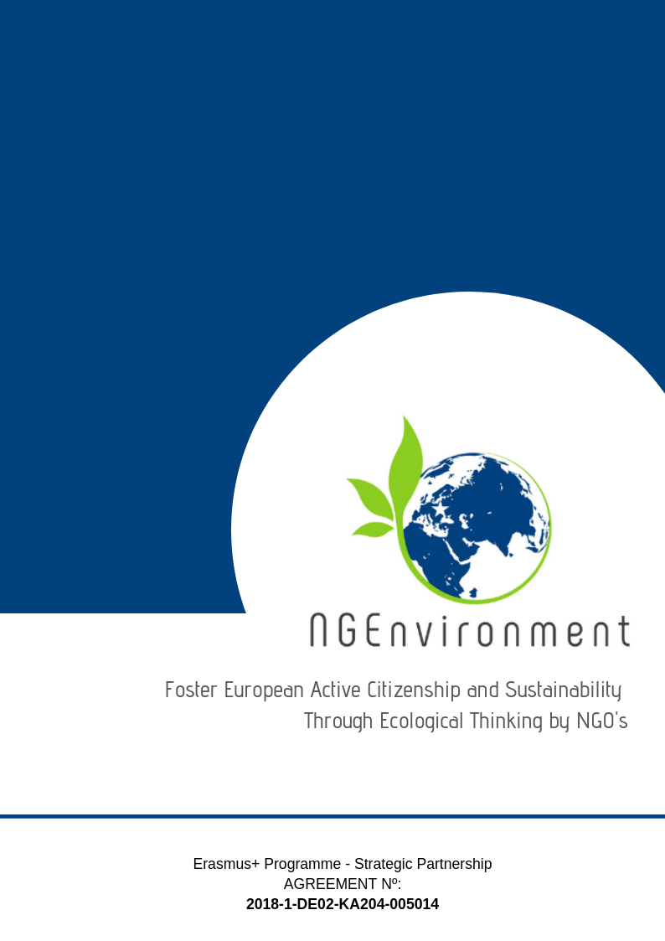­­­­­­­-­

IO5 – NATIONAL RESEARCH REPORT (GERMANY)

Prepared by University of Paderborn

# Heading 1 – Arial 18

Sample Heading

## Heading 2 – Arial 14

Sample Subtitle

Lorem ipsum dolor sit amet, consectetur adipiscing elit. Praesent id lectus tortor. Integer aliquam neque vel arcu scelerisque, non auctor metus efficitur. Aenean dolor enim, suscipit non tellus sit amet, posuere semper enim. Sed eu dolor turpis. Pellentesque maximus justo et est mattis, a pharetra ex convallis. Quisque nec risus eu metus ultricies semper. Duis eu velit vehicula ipsum egestas rhoncus id quis tellus. Curabitur rutrum nunc elit, a fringilla arcu facilisis vestibulum. Morbi convallis quam sit amet tellus convallis auctor. Mauris in dictum dui. Nulla vitae bibendum sem. Donec ut finibus tortor. Vestibulum ante ipsum primis in faucibus orci luctus et ultrices posuere cubilia Curae; Quisque quis enim id ex faucibus congue.

Suspendisse potenti. Nulla facilisi. Etiam efficitur enim eu velit interdum, eu egestas quam cursus. Sed dapibus, magna id facilisis rutrum, erat diam hendrerit ligula, id cursus felis orci eget sem. Donec efficitur mauris condimentum, mollis odio id, commodo elit. Praesent tempor pretium finibus. Sed id erat vitae metus tristique elementum.

Donec euismod ipsum non nisi sodales rhoncus. Sed ac velit hendrerit, eleifend nulla nec, faucibus mauris. Sed auctor magna vitae tortor fermentum, non dapibus nisi vulputate. Phasellus faucibus nulla nec feugiat ullamcorper. Praesent blandit faucibus dolor a ornare. Aliquam sit amet odio hendrerit dolor vulputate malesuada ac sit amet erat. Proin scelerisque vel elit ac dignissim. Praesent ullamcorper orci id dui porttitor malesuada. Ut sollicitudin, nisl dapibus molestie varius, nisi leo aliquam est, a semper tortor est nec erat. Praesent vel nisi lobortis, vehicula libero accumsan, bibendum diam. Nunc eu egestas risus. Donec dapibus elit diam, non pretium leo sagittis eu.

Lorem ipsum dolor sit amet, consectetur adipiscing elit. Praesent id lectus tortor. Integer aliquam neque vel arcu scelerisque, non auctor metus efficitur. Aenean dolor enim, suscipit non tellus sit amet, posuere semper enim. Sed eu dolor turpis. Pellentesque maximus justo et est mattis, a pharetra ex convallis. Quisque nec risus

**Table of Contents**

|  |  |  |
| --- | --- | --- |
|  | | **Page** |
|  | |  |
| 1. Introduction | | **2** |
| 1. Main findings | | **3** |
| 1. Conclusions | | **6** |
|  |
|  |

1. **Introduction**

The University of Paderborn has implemented the research in North Rhine-Westphalia, Germany. It has applied the research questionnaire to 20 persons of the target groups and it has got back 20 filled in questionnaires. The questionnaires have been applied face-to-face (6 persons) and by email (14 persons).

The research was achieved in the period 20th of April to 6th of May 2019.

The participants conducted the survey directly paper-based or via e-mail.

In terms of gender,8 respondents are male, 7 are female and 5 participants did not answer this question.

The profile of the participants is presented in table 1 below.

|  |  |  |  |  |  |  |  |  |  |
| --- | --- | --- | --- | --- | --- | --- | --- | --- | --- |
|  |  |  | ***Category*** | | | ***Duration (in years) since activates in the NGO and/or entrepreneurial field*** | | | |
|  | ***Age (years)*** | ***Gender*** | ***1 - potential new NGO leaders*** | ***2 - existing NGO leaders and staff members*** | ***3 - social and green activists*** | ***less than 1 year*** | ***1 to 3 years*** | ***3 to 5 years*** | ***over 5 years*** |
| 1 |  | F | x |  |  | x |  |  |  |
| 2 | 25 | F | x |  |  | x |  |  |  |
| 3 | 27 | F | x |  |  | x |  |  |  |
| 4 | 28 | M | x |  |  | x |  |  |  |
| 5 | 24 | M | x |  |  | x |  |  |  |
| 6 | 36 | F |  | x |  |  |  |  | x |
| 7 | 31 |  |  | x |  |  | x |  |  |
| 8 |  |  | x |  |  | x |  |  |  |
| 9 | 32 | F |  | x |  |  |  | x |  |
| 10 | 37 | M |  |  | x |  |  |  | x |
| 11 | 42 | M | x |  |  |  |  |  | x |
| 12 | 38 | M |  | x |  |  |  |  | x |
| 13 |  |  |  |  | x | x |  |  |  |
| 14 |  |  | x |  |  |  |  | x |  |
| 15 | 39 | M |  | x |  |  |  | x |  |
| 16 | 41 | F |  |  | x |  |  |  | x |
| 17 | 41 | M | x |  |  |  |  | x |  |
| 18 |  | F |  | x |  |  |  |  | x |
| 19 |  |  |  |  | x |  |  | x |  |
| 20 | 42 | M | x |  |  |  |  |  | x |
| **Total** | | | **10** | **6** | **4** | **7** | **1** | **5** | **7** |

Table 1: Participants’ profile

The data in the table above provided the following statistics:

* the age range of the respondents spans from 24 to 42 years, with an average of 34.5 years;
* the gender distribution among respondents was: 8 persons were men (53%) and 7 persons were women (46.7%); 25% did not provide any information about their gender
* the split of the respondents in envisaged categories was: 50% potential new NGO leaders, 30% existing NGO leaders and staff members and 20% social and green activists;
* 35% of the respondents have less than 1-year experience in the NGO and/or entrepreneurial field, 5% an experience from 1 to 3 years, 25% from 3 to 5 years and 35% over 5 years of such experience.

Figure 1: Distribution of the participants with working experiences in years

1. **Main findings**

When asked about ***what kind of information and dissemination materials they are interested to receive regarding your actual/potential NGO or business, though various informational and dissemination materials*** (Question 1), the answers displayed a quite large variety of such materials, as shown in table 2.

**Table 2:** ***Information and materials of interest (N=19)***

|  |  |  |  |  |  |
| --- | --- | --- | --- | --- | --- |
| ***Information and materials of interest*** | ***(N)*** | ***%*** | ***Information and materials of interest*** | ***(N)*** | ***%*** |
| Legislation for NGOs and regarding volunteering and how to implement this issue correctly | 5 | 26.32 | Active or future projects | 1 | 5.26 |
| Success factors (for NGOs and active citizenship) | 8 | 42.11 | Incentives | 1 | 5.26 |
| Examples of good practices | 9 | 47.37 | Profits | 0 | 0 |
| Useful links (i.e. for NGO field and entrepreneurial environment, about ongoing projects in the online environment) | 3 | 15.79 | Newsletters | 0 | 0 |
| Risks (for sustainability of NGOs) | 13 | 48.42 | Flyers | 0 | 0 |
| Statistics | 2 | 10.53 | Case studies | 1 |  |
| Resources and support materials for NGO activities and NGO ecological thinking | 5 | 26.32 | Events | 0 | 0 |
| Supporting agencies/authorities for environmental and social NGOs | 7 | 26.84 | Funding opportunities | 1 | 5.26 |
| Benefits | 11 | 57.89 | Partnerships | 0 | 0 |
| Contacts with other NGOs | 0 | 0 | Characteristics of green NGOs | 7 | 26.84 |
| Obstacles | 4 | 21.05 |  |  |  |

Table 2: Information and materials of interest

As one can see from Table 2 above, *benefits* (58%), *risks* (48%), *examples of good practices* (47%) and *success factors* (42%) are considered as being the most important for NGO leaders.

The question about ***types of materials the respondents usually access (have access to) for getting information and news within the NGO field and entrepreneurial environment*** (Question 2) revealed that the project target groups use all types of existing informational materials, with the most preferred being the *brochures (45%), magazines (35%), policy papers (35%) and flyers (30%)* on topics of interest, as shown by Table 3.

**Table 3: *Types of informational materials accessed (N=20)***

|  |  |  |  |  |  |
| --- | --- | --- | --- | --- | --- |
| ***Type of materials*** | ***(N)*** | ***%*** | ***Type of materials*** | ***(N)*** | ***%*** |
| Flyers | 6 | 30.0 | Advertisements | 0 | 0 |
| Brochures | 9 | 45.0 | Journals | 11 | 55.0 |
| Articles | 5 | 25.0 | Newspapers (ordinary or specialised) | 8 | 40.0 |
| Statistics | 4 | 20.0 | Curricula | 1 | 5.0 |
| Magazines | 7 | 35.0 | Books | 3 | 15.0 |
| Guidelines | 5 | 25.0 | Announcements | 3 | 15.0 |
| Newsletters | 3 | 15.0 | Leaflets | 4 | 20.0 |
| Reports | 1 | 5.0 | Handbooks | 3 | 15.0 |
| Policy papers | 7 | 35.0 | Toolkits | 0 | 0 |
| Posters | 3 | 15.0 | Handouts | 1 | 5.0 |
| Reviews | 2 | 10.0 | Other: online documents, specialised websites ([www.fonduristructurale.ro](http://www.fonduristructurale.ro) [www.stiri.ong](http://www.stiri.ong) , etc.), Internet, websites of the financers | 3 | 15.0 |

Table 3: Types of informational materials accessed

When asked about ***what kind of materials they would like to receive*** ***about the NGEnvironment project and its outcomes*** the respondents listed various types of materials as shown in Table 4 below with *good practices guide and guidelines (50%) and project structure/ core ideas (44%), web information/ information for download (28%)* and *leaflets (22%)*.

**Table 4: *Materials about the NGEnvironment project (N=18)***

|  |  |  |  |  |  |
| --- | --- | --- | --- | --- | --- |
| ***Materials*** | ***(N)*** | ***%*** | ***Materials*** | ***(N)*** | ***%*** |
| Good practices guide and guidelines | 9 | 50.0 | Flyers | 1 | 5.55 |
| Books | 0 | 0.0 | Handbooks | 2 | 11.11 |
| Brochures | 1 | 5.55 | Magazines | 1 | 5.55 |
| Reviews | 1 | 5.55 | Articles | 1 | 5.55 |
| Reports | 1 | 5.55 | Web information/ information for download | 5 | 27.78 |
| Statistics | 1 | 5.55 | Leaflets | 4 | 22.22 |
| Social outcome/ integration of social institutions | 3 | 16.67 | Workshops | 1 | 5.55 |
| Project structure/ core ideas | 8 | 44.44 | Policy Papers | 1 | 5.55 |

Table 4: Materials about the NGEnvironment project

The ***dissemination and advertising channels*** (Question 4) are presented in Table 5, with the most preferred being, per category, (i) *websites* (85%), (ii) *written press (85%),* *workshops* (70%), and *social media* for online environments *(35%)* and *blogs* (35%).

**Table 5: *Dissemination and advertising channels (N=20)***

|  |  |  |  |  |  |  |  |  |
| --- | --- | --- | --- | --- | --- | --- | --- | --- |
| ***Online*** | ***(N)*** | ***%*** | ***Face-to-face*** | ***(N)*** | ***%*** | ***Press*** | ***(N)*** | ***%*** |
| Social media (Facebook, Twitter, WhatsApp, Instagram, etc.) | 7 | 35.0 | Meetings | 1 | 5.0 | TV | 3 | 15.0 |
| Emails | 4 | 20.0 | Seminars | 8 | 40.0 | Written press | 17 | 85.0 |
| Websites | 17 | 85.0 | Workshops | 14 | 70.0 | Radio | 2 | 10.0 |
| Blogs | 7 | 35.0 | Round tables | 3 | 15.0 | Other: press conference, online press, internet press | 2 | 10.0 |
| Skype, Zoom, WEBex, etc. | 0 | 0.00 | Conferences | 4 | 20.0 |  |  |  |
| Other: WIKI, You Tube | 2 | 10.0 | Info fairs | 2 | 10.0 |  |  |  |
|  |  |  | Thematic/specialised exhibitions | 1 | 10.0 |  |  |  |
|  |  |  | Information centres | 7 | 35.0 |  |  |  |
|  |  |  | Civic events (peaceful marches, demonstrations, etc.) | 2 | 10.0 |  |  |  |

Table 5: Dissemination and advertising channels

The most impactful ***support-media when it is about the NGEnvironment Engagement Toolkit*** (Question 5)are the *online-media (85%)*, *video (50%)* and *print* (70%) according to our respondents’ opinion, as displayed in table 6 below.

**Table 6: *Most impactful support-media about the NGEnvironment Engagement Toolkit (N=20)***

|  |  |  |  |  |  |
| --- | --- | --- | --- | --- | --- |
| ***Materials*** | ***(N)*** | ***%*** | ***Materials*** | ***(N)*** | ***%*** |
| Video | 10 | 50.0 | Mobile phones | 2 | 10.0 |
| Online | 17 | 85.0 | PC and PC-Tablets | 2 | 10.0 |
| Audio | 4 | 20.0 | Print | 14 | 70.0 |
| Memory sticks | 4 | 20.0 | CD-ROM | 1 | 5.00 |

Table 6: Most impactful support-media about the NGEnvironment Engagement Toolkit

In terms of ***technologies that would arouse the respondents’ interest and motivate them better to learn about the NGEnvironment project and to make efficient use of its outcomes*** (Question 6), the *web-based technologies* are recorded at highest score with 95%. But even so the *mobile technologies* are rated quiet high with 55% and the *multimedia technology* with 20%.

**Table 7: *Technologies for a better learning about NGEnvironment project (N=20)***

|  |  |  |
| --- | --- | --- |
| ***Technologies*** | ***(N)*** | ***%*** |
| Web-based technologies | 19 | 95.0 |
| Mobile technologies | 11 | 55.0 |
| Hypermedia technology | 3 | 15.0 |
| Multimedia technology | 4 | 20.0 |
| Other | 0 | 0.00 |

Table 7: Technologies for a better learning about NGEnvironment project

Regarding ***how they would like the provided information to be structured / approached within the materials that the NGEnvironment consortium will prepare for them and include in the project’s Engagement Toolkit*** (Question 7), the majority of the respondents would appreciate *a very structured (concise) information and with provided links for more details* (N = 20, 70%). Even so, the participants rated the *sequential information (‘portions’ of information delivered one after the other, provided at different stages in project’s lifetime)* only with 35%.

**Table 8: *Information for project´s Engagement Toolkit (N=20)***

|  |  |  |
| --- | --- | --- |
| ***Information*** | ***(N)*** | ***%*** |
| Very structured (concise) and with provided links for more details | 14 | 70.0 |
| Complete, with all details at once | 1 | 5.00 |
| Sequential (“portions” of information delivered one after the other, provided at different stages in project´s lifetime) | 7 | 35.0 |

Table 8: Information for project´s Engagement Toolkit

Regarding ***any necessary recommendations for the NGEnvironment consortium regarding the development of contents and materials to be included in the project’s Engagement Toolkit*** (Question 8), we got only few but relevant answers:

* *Give short overviews (for quick readers/ One-Pagers (28%)*
* *Provide a linklist and information with addresses of other people in the same situation/ create a network (9%)*
* *Handbook of learners (9%)*
* *More transparency of results (9%)*
* *Involvement of aspects on sustainable and green issues/ integration of social aspects (18%)*
* *Information regarding the modules (9%)*
* *More information about Engagement Toolkit (9%)*

1. **Conclusions**

The findings of the survey with the three different target group gives interesting and important insights. This is very useful, because the findings will assist to inform the development phase for the Engagement Toolkit in the project of NGEnvironment.

Most of the participants are interested in receiving information about the following topics: *benefits*, *risks*, *examples of good practices* and *success factors*. This finding is not surprising, because NGOs are also business and to be informed about risks or best practice instances are always useful.

Even so, the findings show that the target group prefers the providing of information by paper-based material as *brochures, flyers, and magazines or policy-paper*. Also, these findings are not surprising. The readers are interested in the latest news in the NGO field and a flyer or a brochure provides the most important facts in a short version. For a more detailed report is the use of a magazine useful. Besides the policy paper provides the target group with best practice information.

Furthermore, the participants like to receive information about the NGEnvironment and its outcome via *good practices guide and guidelines*.

The target group prefers to receive these important *online* facts, information and supporting material per *social media* or the *website*. These dissemination and advertising channels are quick and modern. But in case of providing these information, facts and supporting material *face-to-face* the target group prefers *workshops and seminars.* Besides by using the press the written press I preferred by the participants.

Based on evaluation findings, *print, video and online media* needs to be a ‘must-have’ for the NGEnvironment Engagement Toolkit. This indicates that the consortium needs to take them into account, as well as *web-based and multimedia technologies*.

In relation to kind of providing the information of the NGEnvironment Engagement Toolkit, the participants showed that they prefer a *very structured (concise) approach and with given links for more details.*

The recommendations of the participants show that the consortium should provide relevant information in a ‘short version’ like one-pager overview. But even so, it would be important to involve aspects on sustainable and green issues.

**In conclusion, the findings show very clear that there is a huge need of the target group to receive supporting material in form of practical advices and guidelines. Furthermore, the target group prefers a fast way of receiving this information online and in short versions like flyers and brochures. Besides, the approach and idea of the *NGEnvironment Engagement Toolkit fit very well with the target groups needs and preferences. Therefore, we are pretty sure there will be a good match between the supply and the demand in relation to the toolkit features and the research findings.***

