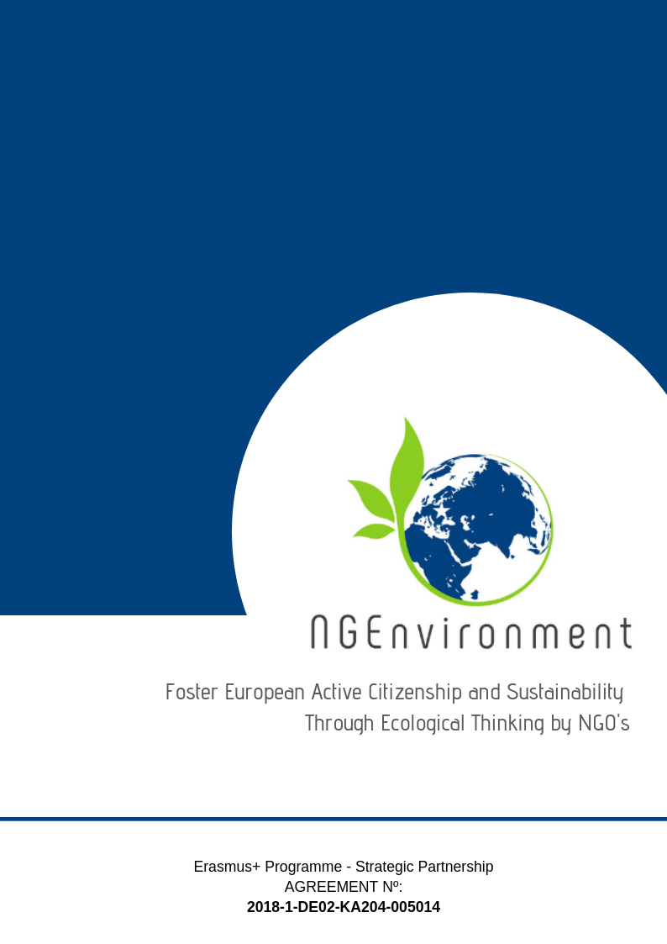
Society of Environmental Educational Innovation (EPEK)
IO5 – NATIONAL RESEARCH REPORT

Table of Contents
Page
- Introduction 4

- Main findings 5

- Conclusions 8

- Introduction

The Society of Environmental Educational Innovation (EPEK) has implemented the research in Korinthos city as well as in Peloponnese region. It has applied the research questionnaire to 25 persons of the target groups and it has got back 17 filled in questionnaires. The questionnaires have been applied face-to-face (5 persons); by phone (8 persons) and by email (4 persons).
The research was achieved in the period 31st of March to 2^{h} of May 2019.

The profile of the respondents is presented in Table 1 below.

Table 1: Respondents’ profile
 |  |  | Category |  |  | Duration (in years) since activates in the NGO and/or entrepreneurial field
 | Age (years) | Gender | 1 - potential new NGO leaders | 2 - existing NGO leaders and staff members | 3 - social and green activists | less than 1 year | 1 to 3 years | 3 to 5 years | over 5 years
1 | 20 | M |  |  |  |  |  |  | X
2 | 21 | F |  | X | X |  | X
3 | 21 | F | X |  |  | X
4 | 23 | M |  |  | X |  | X
5 | 24 | F |  | X |  |  | X
6 | 24 | M | X |  |  | X
7 | 29 | M | X |  |  | X
8 | 31 | F |  |  | X |  |  | X
9 | 33 | M |  | X |  |  | X
10 | 36 | F | X |  |  | X |  |  | X
11 | 41 | F |  |  | X |  |  | X
12 | 44 | F | X |  |  | X |  |  | X
13 | 47 | M |  | X |  |  |  | X
14 | 51 | M |  | X |  |  | X
15 | 56 | F |  |  | X |  |  |  | X
16 | 58 | M |  | X |  |  |  |  | X
17 | 62 | M |  | X |  |  |  |  | X
Total |  |  | 5 | 7 | 5 | 5 | 5 | 3 | 6

The data in the table above provided the following statistics:
- the age range of the respondents spans from 20 to 62 years, with an average of 36.5 years;
- the gender distribution among respondents was: 9 persons were men (53%) and 8 persons were women (47%);

- the split of the respondents in envisaged categories was: 29,5% potential new NGO leaders, 41,2% existing NGO leaders and staff members and 29,5% social and green activists;

- 29.5% of the respondents have less than 1-year experience in the NGO and/or entrepreneurial field, 29.5% an experience from 1 to 3 years, 29.5% from 3 to 5 years and 17,7% over 5 years of such experience 35,3%.

- Main findings

When asked about what kind of information and dissemination materials they are interested to receive regarding your actual/potential NGO or business, though various informational and dissemination materials (Question 1), the answers displayed a quite large variety of such materials, as shown in Table 2.

Table 2: Information and materials of interest
Information and materials of interest | (N) | %
Legislation for NGOs and regarding volunteering and how to implement this issue correctly | 14 | 82,4
Examples of good practices | 6 | 35,3
Useful links (i.e. for NGO field and entrepreneurial environment, about ongoing projects in the online environment) | 5 | 29,5
Newsletters | 9 | 53
Flyers | 9 | 53
Resources and support materials for NGO activities and NGO ecological thinking | 7 | 41,2
Supporting agencies/authorities for environmental and social NGOs | 5 | 29,5
Partnerships | 8 | 47
Contact with other NGOs | 5 | 29,5
Funding Opportunities | 14 | 82,4
Active for future projects | 9 | 53
Summer schools | 2 | 11,8
Activity in social media | 13 | 76,5
Production articles | 5 | 29,5

As one can see from Table 2 above, legislative aspects, funding opportunities, activity in social media and newsletters are considered as being the most important for NGO leaders.

The question about types of materials the respondents usually access (have access to) for getting information and news within the NGO field and /entrepreneurial environment (Question 2) revealed that the project target groups use all types of existing informational materials, with the most preferred being the flyers, brochures and articles on topics of interest, as shown by Table 3.

Table 3: Types of informational materials accessed
Type of materials | (N) | % | Type of materials | (N) | %
Flyers | 9 | 53 | Advertisements | 5 | 29.5
Brochures | 11 | 65 | Journals | 3 | 17.7
Articles | 8 | 47 | Newspapers (ordinary or specialised) | 4 | 23.5
Statistics | 6 | 35.3 | Curricula | 2 | 11.8
Magazines | 10 | 59 | Books | 3 | 17.7
Guidelines | 14 | 82,4 | Announcements | 4 | 23.5
Newsletters | 11 | 65 | Leaflets | 3 | 17.7
Reports | 7 | 41.2 | Handbooks | 2 | 11.8
Policy papers | 4 | 23.5 | Toolkits | 2 | 11.8
Reviews | 6 | 35.3 | Other: online documents, specialised websites (www.fonduristructurale.ro www.stiri.ong , etc.), Internet, websites of the financers

When asked about what kind of materials they would like to receive about the NGEnvironment project and its outcomes (Question 3) the respondents listed various types of materials as shown in Table 4 below with (i) Brochures, (ii) good practices guide and guidelines, and (ii) books on top. Also, very specific have been articles, magazines and flyers.

Table 4: Materials about the NGEnvironment project
Materials | (N) | % | Materials | (N) | %
Good practices guide and guidelines | 14 | 82.4 | Flyers | 4 | 23.5
Books | 7 | 41.2 | Articles | 6 | 35.3
Brochures | 13 | 76.5 | Magazines | 5 | 29.5
Reviews | 4 | 23.5

The dissemination and advertising channels (Question 4) are presented in Table 5, with the most preferred being, per category, (i) social media for online environments, (ii) Meetings for face to face channels, (iii) TV when it is about the press.

Table 5: Dissemination and advertising channels
Online | (N) | % | Face-to-face | (N) | % | Press | (N) | %
Social media (Facebook, Twitter, Instagram, etc.) | 15 | 88.3 | Meetings | 14 | 82.4 | TV | 14 | 82.4
Emails | 12 | 71 | Seminars | 10 | 59 | Written press | 9 | 53
Websites | 13 | 76.5 | Workshops | 11 | 65 | Radio | 5 | 29.5
Blogs | 7 | 41.2 | Round tables | 7 | 41.2 | Other: press conference, online press | 3 | 17.7
Skype | 4 | 23.5 | Conferences | 4 | 23.5
 |  |  | Info fairs | 5 | 29.5
 |  |  | Thematic/specialised exhibitions | 5 | 29.5
 |  |  | Information centres | 9 | 53
 |  |  | Civic events (peaceful marches, demonstrations, etc.) | 11 | 65

The most enflouencial support-media when it is about the NGEnvironment Engagement Toolkit (Question 5) are the video and online media, according to our respondents’ opinion, as displayed on Table 6 below.

Table 6: Most impactful support-media about the NGEnvironment Engagement Toolkit
Materials | (N) | % | Materials | (N) | %
Video | 13 | 76.5 | Mobile phones | 8 | 47
Online | 13 | 76.5 | PC and PC-Tablets | 9 | 53
Audio | 7 | 41.2 | Print | 5 | 29.5
Memory sticks | 6 | 35.3 | CD-ROM | 2 | 11.8

In terms of technologies that would arouse the respondents’ interest and motivate them better to learn about the NGEnvironment project and to make efficient use of its outcomes (Question 6), the mobile technologies have recorded the highest scores with 88.3% (N = 15) and follows the web-based technologies (N = 10) followed by multimedia technologies 29.5% (N = 5) and hypermedia technology 23.5% (N = 4).

Regarding how they would like the provided information to be structured / approached within the materials that the NGEnvironment consortium will prepare for them and include in the project’s Engagement Toolkit (Question 7), the majority of the respondents would appreciate very structured (concise) information and with provided links for more details (N = 15, 88.3%), while only reduced percentages of NGOs leaders would prefer complete information, with all details at once (N = 6, 35.3%) or sequential information (‘portions’ of information delivered one after the other, provided at different stages in project’s lifetime) (N = 2, 11.8%).

Regarding any necessary recommendations for the NGEnvironment consortium regarding the development of contents and materials to be included in the project’s Engagement Toolkit (Question 8), we got only few but relevant answers:
- Give concrete results, procedures and methodologies, as well as applications;
- Inform about Ecological Thinking and how it helps to live a better life;
- Give information about how the ecological thinking provides the successful development of ecosystems;
- Provide information on how ecological science helps to address ecological problems by providing scientific methodologies, metrics and terminology.
- Give information about green growth;
- Give more information about the project
- Conclusions
The interpretation of the findings of our research, lead to the following conclusions:

The Greek project target groups are interested to get information and materials for the field of NGO or business upon specific issues like legislation for NGOs, volunteering and how to implement volunteering correctly, for NGOs and funding opportunities and also a correct way for activity in social media to promote their NGOs or business.

The most accessed types of informational materials by them are: the guidelines brochures and newsletters. And again, good practices guide & guidelines are mentioned as first preference when it is about receiving materials about the NGEnvironment project and its outcomes, which makes a good coherence with what kind of materials our target groups generally use/access, providing in the same time, to NGEnvironment consortium a good indication on what kind of materials we should prepare for the project Engagement Toolkit.

Social media, websites, meetings & workshops and TV channels are the dissemination and advertising channels that NGEnvironment should use, in order to according to the preferences of the Greek target groups. We have to emphasize here that the social media got a very high score (88.3%), with Meetings (82.4) in face to face communication and TV (82.4) in press.

Web-based and multimedia technologies video and online media proved to be a ‘must’ for the NGEnvironment Engagement Toolkit.

The majority of our respondents seems to prefer very structured (concise) information and with links available for more details.

As recommended by our respondents, an important aspect to be considered by our consortium when designing the NGEnvironment Engagement Toolkit is that we should include also information on how can the ecological thinking provide the successful development of ecosystems and also how ecological science helps to address ecological problems by providing scientific methodologies, metrics and terminology.

In short, we believe that these findings are realistic and the research helps both new NGO leaders, staff and social and green activists to come in touch each one with others and to understand completely the meaning of ecological thinking and acting too.

