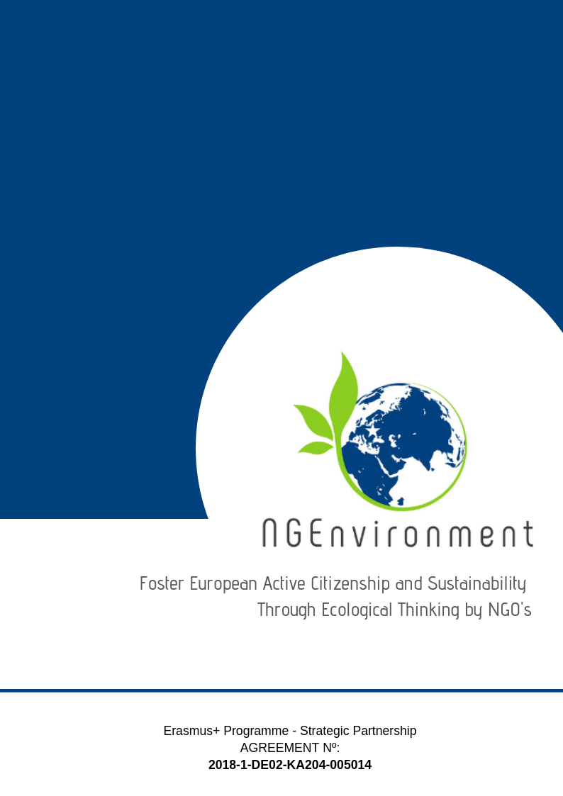­­­­­­­-­

IO5 – NATIONAL RESEARCH REPORT

Future in Perspective Ltd

# Heading 1 – Arial 18

Sample Heading

## Heading 2 – Arial 14

Sample Subtitle

Lorem ipsum dolor sit amet, consectetur adipiscing elit. Praesent id lectus tortor. Integer aliquam neque vel arcu scelerisque, non auctor metus efficitur. Aenean dolor enim, suscipit non tellus sit amet, posuere semper enim. Sed eu dolor turpis. Pellentesque maximus justo et est mattis, a pharetra ex convallis. Quisque nec risus eu metus ultricies semper. Duis eu velit vehicula ipsum egestas rhoncus id quis tellus. Curabitur rutrum nunc elit, a fringilla arcu facilisis vestibulum. Morbi convallis quam sit amet tellus convallis auctor. Mauris in dictum dui. Nulla vitae bibendum sem. Donec ut finibus tortor. Vestibulum ante ipsum primis in faucibus orci luctus et ultrices posuere cubilia Curae; Quisque quis enim id ex faucibus congue.

Suspendisse potenti. Nulla facilisi. Etiam efficitur enim eu velit interdum, eu egestas quam cursus. Sed dapibus, magna id facilisis rutrum, erat diam hendrerit ligula, id cursus felis orci eget sem. Donec efficitur mauris condimentum, mollis odio id, commodo elit. Praesent tempor pretium finibus. Sed id erat vitae metus tristique elementum.

Donec euismod ipsum non nisi sodales rhoncus. Sed ac velit hendrerit, eleifend nulla nec, faucibus mauris. Sed auctor magna vitae tortor fermentum, non dapibus nisi vulputate. Phasellus faucibus nulla nec feugiat ullamcorper. Praesent blandit faucibus dolor a ornare. Aliquam sit amet odio hendrerit dolor vulputate malesuada ac sit amet erat. Proin scelerisque vel elit ac dignissim. Praesent ullamcorper orci id dui porttitor malesuada. Ut sollicitudin, nisl dapibus molestie varius, nisi leo aliquam est, a semper tortor est nec erat. Praesent vel nisi lobortis, vehicula libero accumsan, bibendum diam. Nunc eu egestas risus. Donec dapibus elit diam, non pretium leo sagittis eu.

Lorem ipsum dolor sit amet, consectetur adipiscing elit. Praesent id lectus tortor. Integer aliquam neque vel arcu scelerisque, non auctor metus efficitur. Aenean dolor enim, suscipit non tellus sit amet, posuere semper enim. Sed eu dolor turpis. Pellentesque maximus justo et est mattis, a pharetra ex convallis. Quisque nec risus

**Table of Contents**

Introduction 2

Demographic profile of research participants 2

Main Findings 3

Conclusions 7

# **Introduction**

This short research report presents the findings from the field-based research conducted by FIP to inform the development of the NG-Environment Engagement Toolkit (IO5). To complete this research, FIP applied the research questionnaire developed by GIE to Google Forms and distributed the questionnaire online to our contacts in local NGOs, community groups and among activist groups in our region. FIP achieved in reaching the research target of 15 participants. The following report provides a summary of the responses collected from this research group.

## ***Demographic profile of research participants***

To complete the National Research Report from Ireland for IO5, FIP completed the research survey with 15 local representatives of the three project target groups. Of the 15 respondents, only 9 individuals provided their age through the online survey. Of those who gave their age, these individuals were aged between 27 and 34 years.

Out of the 15 respondents who completed the survey, 9 respondents were female, 4 were male and 2 respondents stated that they would ‘rather not say’.

When asked to describe which research target group they were part of, the following roles and titles were mentioned:

* Staff and Leaders of Existing NGO (3)
* Community Group (3)
* Potential NGO Leader (2)
* Green Activist (2)
* Social Activist (2)
* Disability activist (1)
* NGO Manager (2)

When asked about their length of experience in this sector, the research group stated that 6 individuals had been working in their role for between 1 and 3 years; 5 individuals had been working for less than one year; 3 had between 3- and 5-years’ experience and the final respondent had been working in this sector for over 5 years.

# **Main Findings**

When asked what type of information they were interested in receiving regarding their actual or potential NGO or business, research respondents mentioned the following topics that they would like to receive information on through the Engagement Toolkit:

As we can see from this graph, the most popular types of information listed by our research respondents pertain to available resources (26%), benefits and incentives (22%), practices (17%), legislation and obstacles (13%) and statistics (9%). In addition to these topics, three individuals also listed the following topics as being of interest to them:

* Steering the planet towards a resource based economy as apposed the current fiscal based one
* What resources are available and useful information mostly.
* Marketing techniques

NG-Environment partners should bear these topics in mind when developing the resources for the Engagement Toolkit.

When asked what type of dissemination materials they would like this information to be presented in, our research participants gave the following answers:

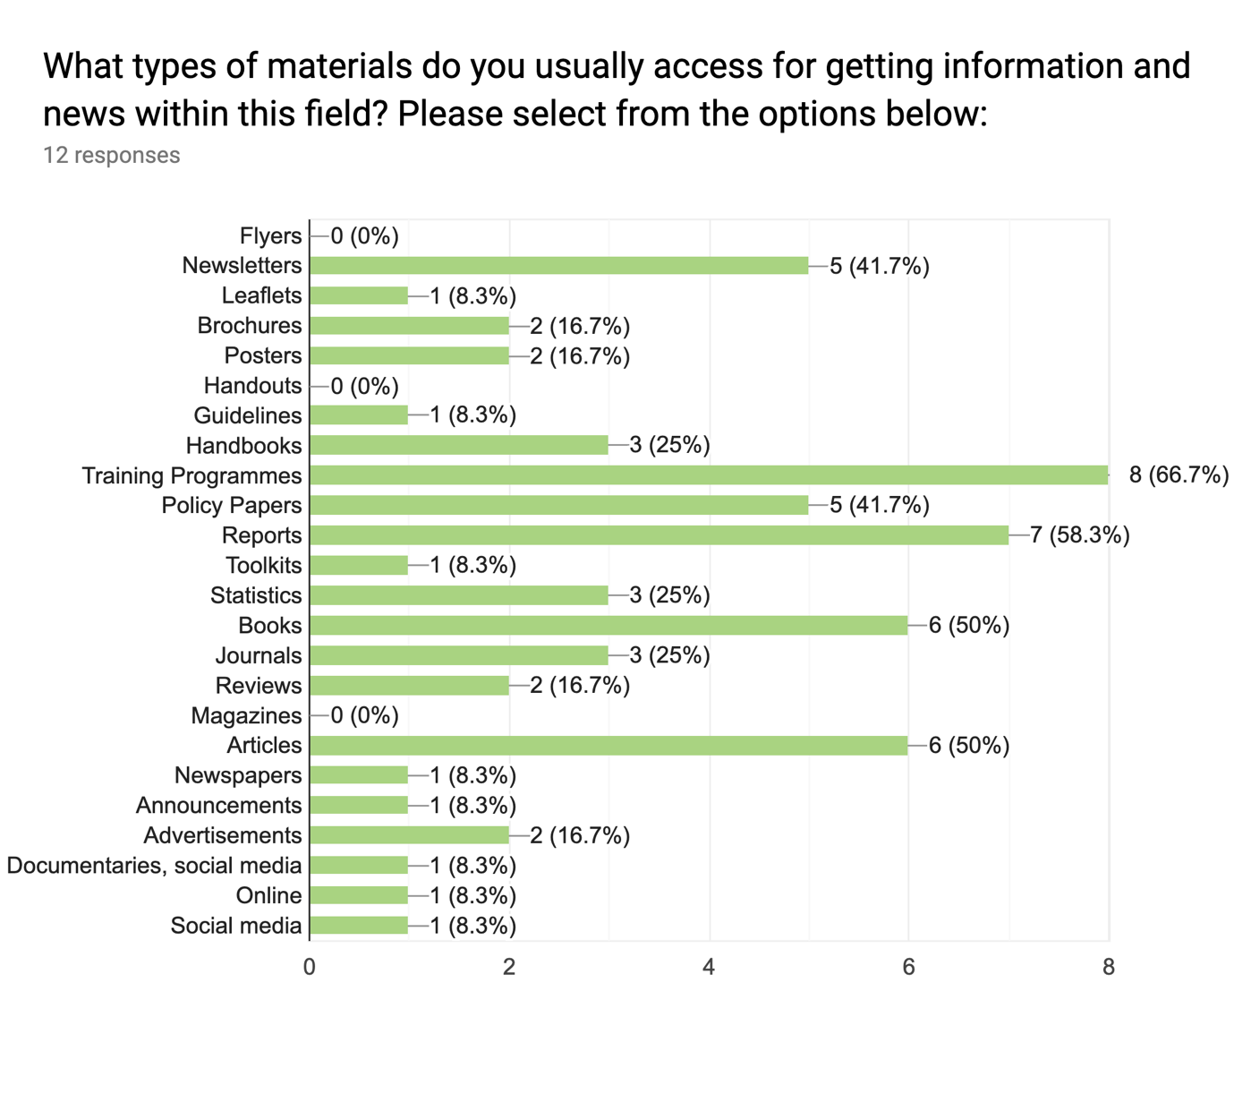

From this graph, we can see that the most popular format for the Engagement Toolkit resources, based on the preferences of our research respondents include:

* Training Programmes (66.7%)
* Reports (58.3%)
* Books and Articles (50%)
* Newsletters and Policy Papers (41.7%)

When asked what format they would like updates and materials developed by the NG-Environment project team to be presented in, research respondents from Ireland mentioned the following formats:

* Online based materials (5)
* Online articles (4)
* Digital newsletters (2)
* Statistics
* Reports
* Anything non paper based
* Social media
* Email
* Training (blended, distance or face-to-face)
* Handbooks
* Printed newsletters
* Journal articles

When asked what kind of advertising channels they prefer in general, research participants from Ireland mentioned the following channels:

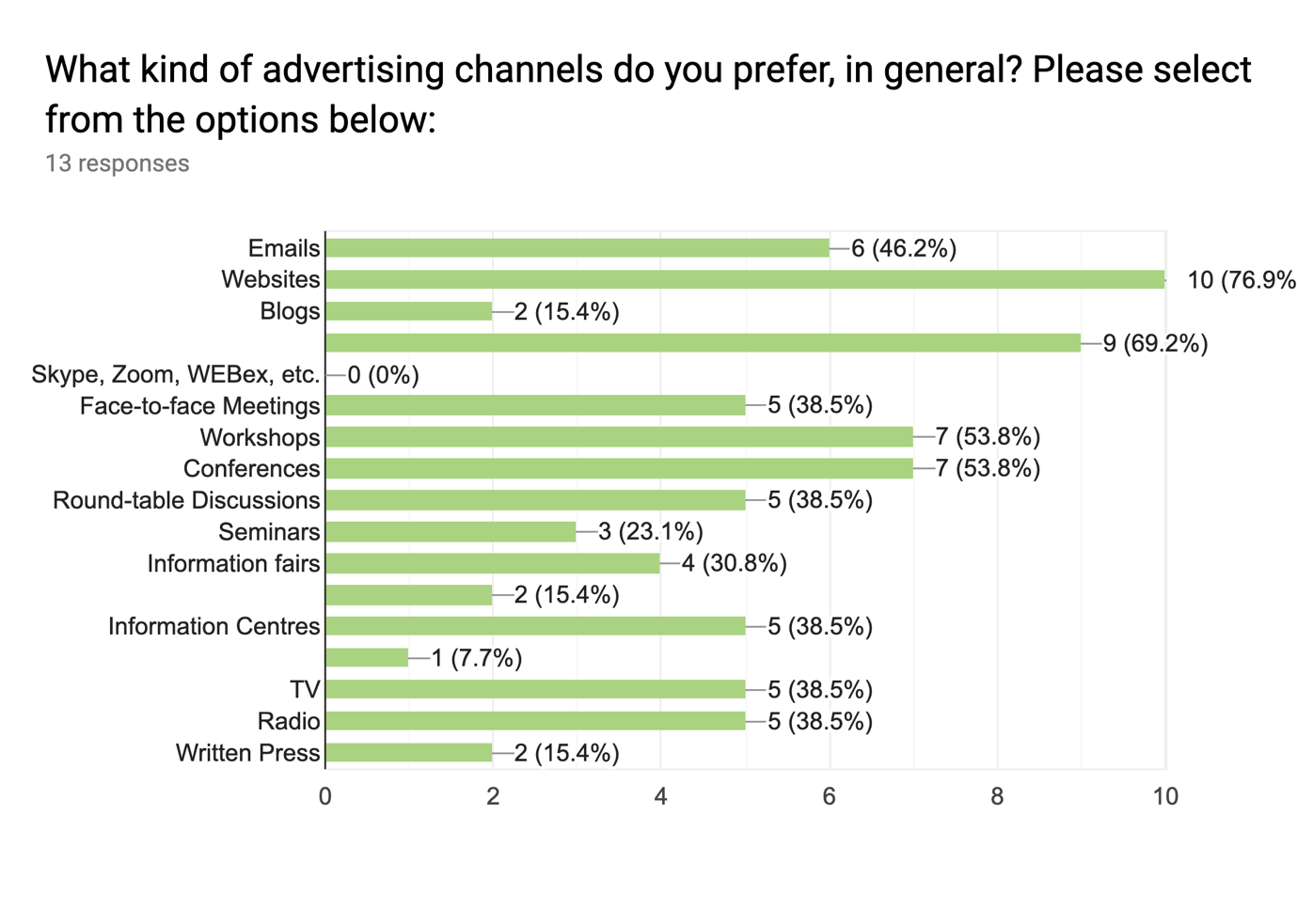

From this graph, we can see that the most popular advertising channels among our research participants include:

* Websites (76.8%)
* Workshops and Conferences (53.8%)
* Emails (46.2%)
* Face-to-face meetings, information centres, TV and radio (38.5%)

Next research respondents were asked to specify format they would like to see the NG-Environment materials presented in. Here, they mentioned the following formats:

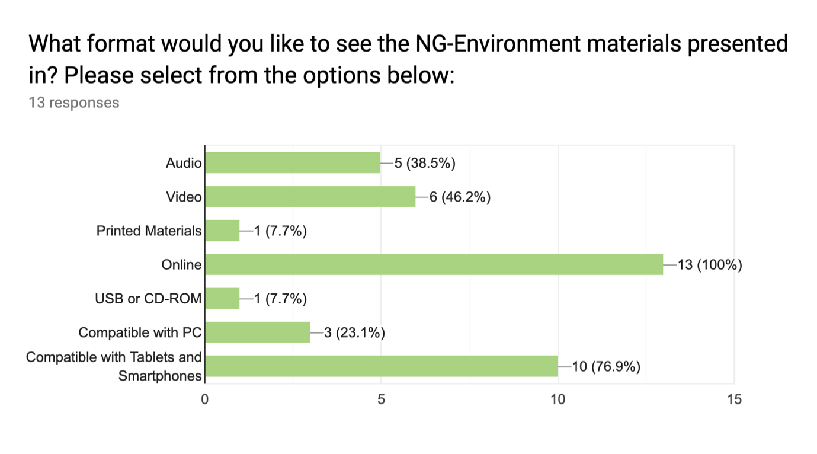

Here, we see that the formats that research participants in Ireland would most like to see NG-Environment materials presented in include:

* Online (100%)
* Material that is compatible with tablets and smartphones (76.9%)
* Video (46.3%)
* Audio (38.5%)

Finally, when asked to specify which technologies would help to motivate them to learn more about the NG-Environment project and to learn from the materials developed by the project, research respondents answered as follows:

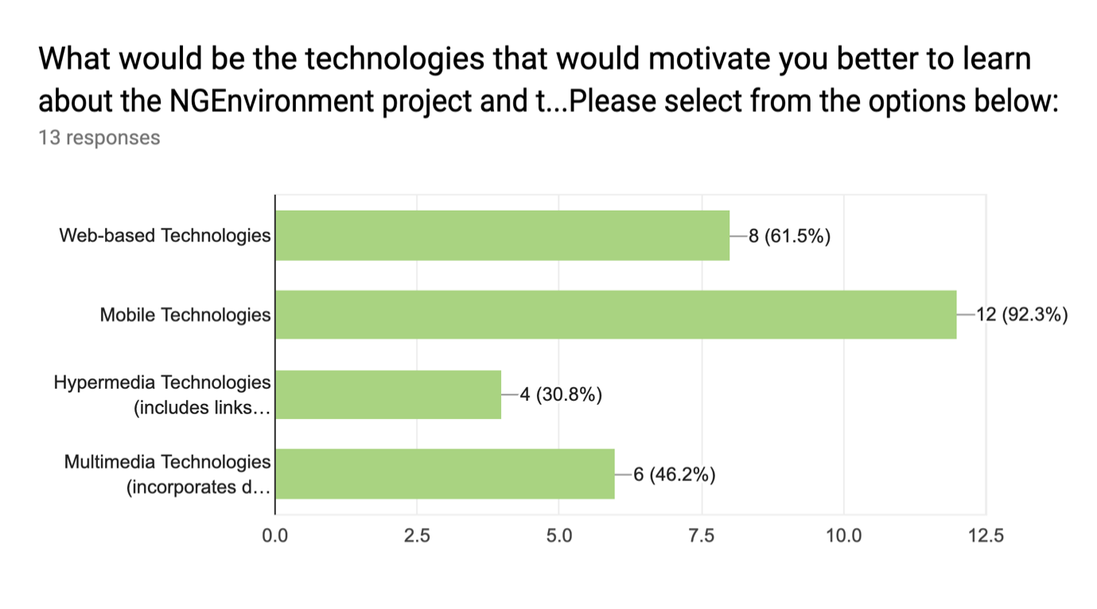

From this graph, we can see that the most popular formats for motivating them to learn through the NG-Environment projects would be materials that are presented through mobile technologies (92.3%), web-based technologies (61.5%) and multi-media technologies (46.2%).

# **Conclusions**

This report has provided an overview of the main research findings collated from the responses gathered from 15 members of the target group in Ireland. What we have learned through this research is that NGO leaders, potential leaders, community members and activists in Ireland would like to receive more information through the NG-Environment project on the following topics: available resources, benefits and incentives, practices, legislation, obstacles and statistics. In addition to these topics, they would also be interested in receiving information on marketing techniques for this sector, useful information and how they can help to steer the planet towards a resource-based economy as apposed the current fiscal-based one.

When asked how they would like this information to be presented, the most popular answers among our research group included: training programmes, reports, books, articles, newsletters and policy papers. Similarly, respondents from Ireland stated that they would like to see materials developed by this project team presented as online materials, that are compatible with smartphones and devices and include elements of video and audio-supported materials. NG-Environment partners should bear these different formats in mind when developing resources for the Engagement Toolkit.

When asked what format they would like updates and materials developed by the NG-Environment project team to be presented in, research respondents from Ireland mentioned a strong preference for online-based materials including articles, newsletters, social media updates, emails, reports, statistics, online training and handbooks. Some also mentioned that they would like to receive updates through printed newsletters and journal articles.

Respondents from Ireland tend to access information through the following advertising channels: websites, workshops, conferences, emails, TV, radio and through face-to-face meeting and visiting information centres.

Lastly, the research group from Ireland shared that they would find materials developed using mobile technologies, web-based technologies and multi-media technologies most motivational. As such, NG-Environment partners should prioritise developing materials using these technologies to ensure that they are engaging to our target group.

