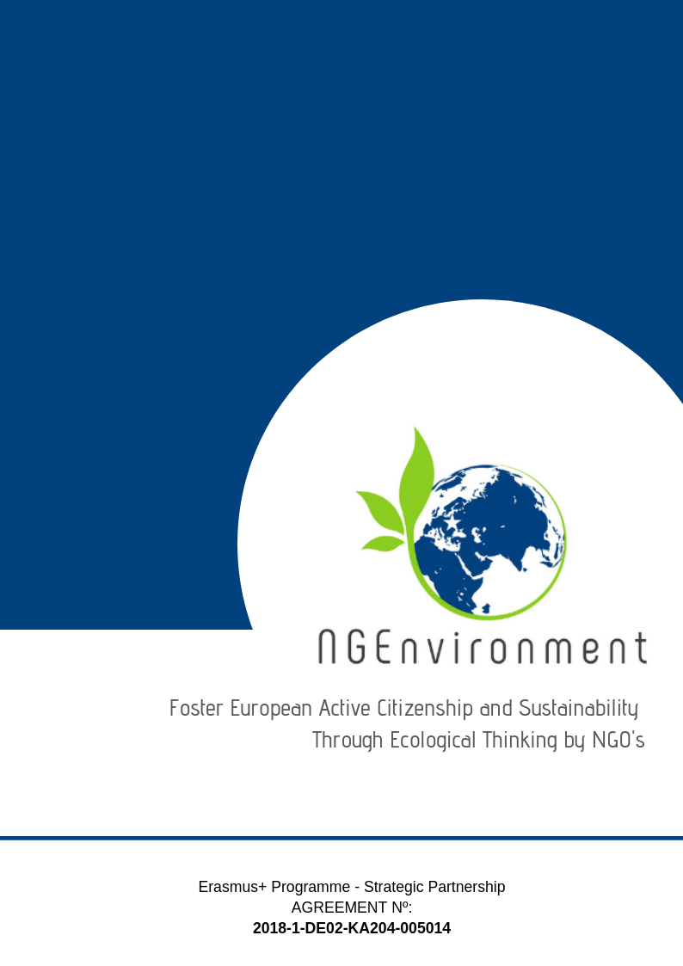­­­­­­­-­

Prepared by SINERGIE

IO5 – IO5 National Research Report (ITALY)

|  |  |
| --- | --- |
| Editor: | Federica Lo Cascio (SINERGIE) |
| Dissemination Level: | Restricted to other programme participants (including Commission services and project reviewers) |
| Status: | Final |
| Preparation Date: | 06.05.2019 |
| Version: | 1 |

**Contributors**

|  |  |  |
| --- | --- | --- |
|  | **Name** | **Organisation** |
| 1 | Federica Lo Cascio | SINERGIE |
| 2 |  |  |
| 3 |  |  |
|  |  |  |
|  |  |  |
|  |  |  |

**Change log**

|  |  |  |
| --- | --- | --- |
| **Name** | **Date** | **Description** |
| Federica L. | 06/05/2019 | Deliver of final version of the document. |
|  |  |  |
|  |  |  |
|  |  |  |

Table of Contents

**Introduction** 3

**Main findings** 4

**Conclusions** 9

# **Introduction**

The Italian National Research Report presents 22 respondents between 19 and 48 years old who completed the online questionnaire (on GoogleForm) that has been disseminated through different channels: Facebook and Linkedin public posts and private messages, Newsletter to a selected target list of stakeholder.

In terms of gender, 12 respondents are male and 10 are female.

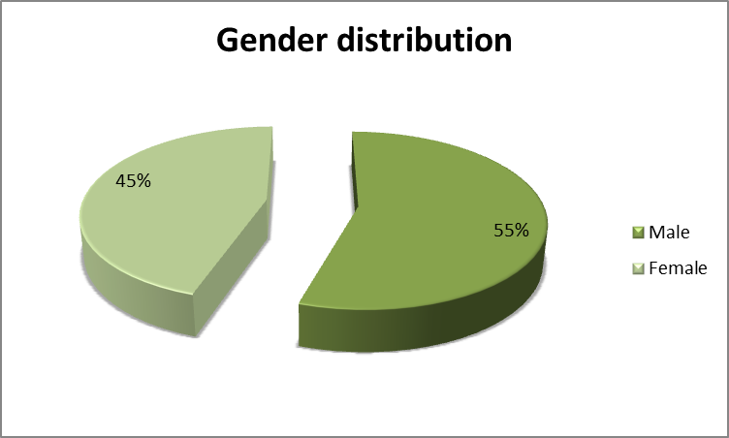

Regarding the category, 13 of the respondents affirmed that they are social and green activists, 5 are NGOs leaders and/or staff members and 4 said they are potential new NGO leaders.

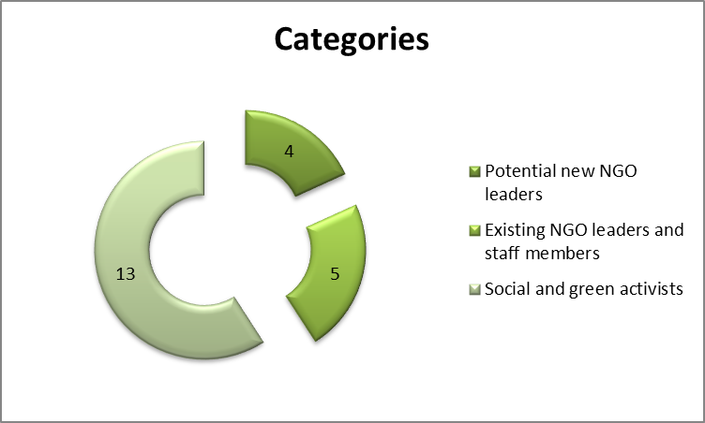

In terms of the length of experience and duration in the NGO/Entrepreneurship field, 8 respondents affirmed that they have more than 5 years of experience, 5 respondents said 3 to 5 years, only 1 respondent enounced 1 to 3 years, and 8 respondents said less than 1 year.

# **Main findings**

**Question 1:** When asked about the kind of information and dissemination materials actual/potential NGO or business they are interested in, respondents said that they would like to know more about:

* Incentives and funding opportunities (11)
* Useful links and networks for collaboration (other NGOs, public authorities and privates) (8)
* Legislation (7)
* Best practices (6)
* Supporting agencies/authorities (6)
* Sources of profit (5)
* Risks (4)
* Success cases (3)
* Statistics (3)
* Success factors (2)
* Scientific findings and researches (2)
* Reliable information sources (1)
* Training opportunities (1)

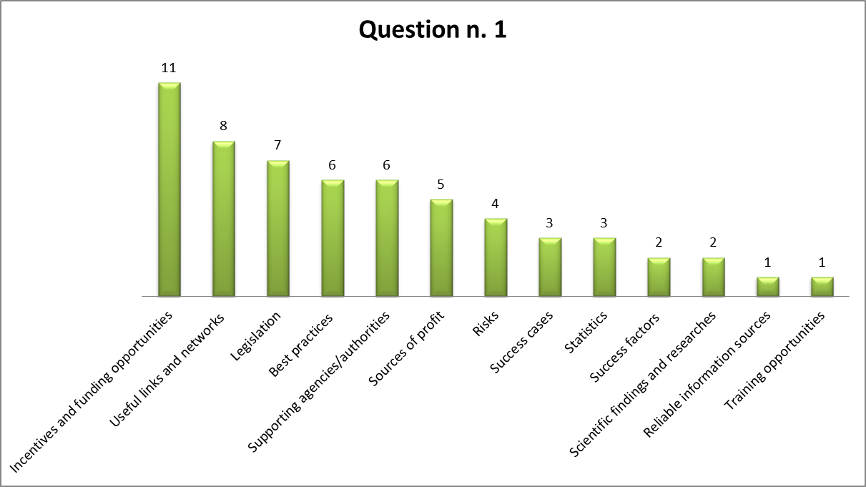

Furthermore, one respondent wrote that having a “reference person” could be of help.

**Question 2:** In terms of materials of interest they usually access for getting information and news within the NGO field and entrepreneurial environment, the Italian respondents prefer articles (15), newsletters (14) and reports (12), guidelines and handbooks (both 7 answers). Table 1 presents the materials of interest referred by the 22 Italian respondents.

**Table 1: Materials of interest**

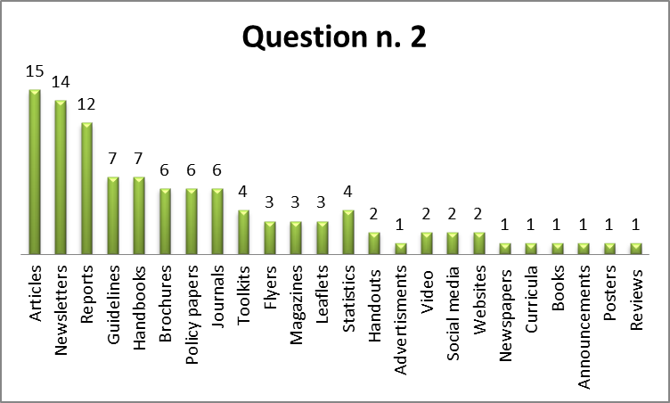

|  |  |
| --- | --- |
| Materials of interest | |
| Articles | 15 |
| Newsletters | 14 |
| Reports | 12 |
| Guidelines | 7 |
| Handbooks | 7 |
| Brochures | 6 |
| Policy papers | 6 |
| Journals | 6 |
| Toolkits | 4 |
| Flyers | 3 |
| Magazines | 3 |
| Leaflets | 3 |
| Statistics | 4 |
| Handouts | 2 |
| Advertisements | 1 |
| Video | 2 |
| Social media | 2 |
| Websites | 2 |
| Newspapers | 1 |
| Curricula | 1 |
| Books | 1 |
| Announcements | 1 |
| Posters | 1 |

**Question 3:** In terms of kind of materials they would like to receive about the NGEnvironment project and its outcomes, the Italian respondents prefer newsletter with different types of contents.

CHANNELS:

* Newsletter (9)
* Brochures, leaflets (1)
* Video pills (1)
* T-shirt with project logo (1)

CONTENTS:

* Project reports (6)
* Informative articles (3)
* Project materials, methods and useful tools (2)
* Statistic data and dashboards (like those made with Tableau[1]) (2)
* Guidelines (1)
* Recommended readings and bibliographic references (1)
* Info about best practices (1)
* Information on the calls and the possibility of financing the activities, information about similar organisations in the territory, contacts with specialized staff (1)

**Question 4:** In terms of dissemination channels, table 2 shows that face-to-face dissemination is the main preference of the 22 Italian respondents, but they are also interested in online channels.

**Table 2: Dissemination channels**

|  |  |
| --- | --- |
| Dissemination and advertising channels | |
| ONLINE | **41** |
| Emails | 11 |
| Websites | 9 |
| Blogs | 4 |
| Social media (Facebook, Twitter, WhatsApp, Instagram, etc.) | 14 |
| Skype, Zoom, WEBex, etc. | 2 |
| other *(please specify here):* Podcast | 1 |
| FACE-TO-FACE | **56** |
| Meetings | 8 |
| Workshops | 10 |
| Conferences | 6 |
| Round tables | 5 |
| Seminars | 7 |
| Info fairs | 6 |
| Thematic/specialised exhibitions | 6 |
| Information centres | 2 |
| Civic events (peaceful marches, demonstrations, etc.) | 6 |
| Other *(please specify here):*…………… | 0 |
| PRESS | **8** |
| TV | 4 |
| Radio | 2 |
| Written press | 2 |
| Other *(please specify here):*…………… | 0 |

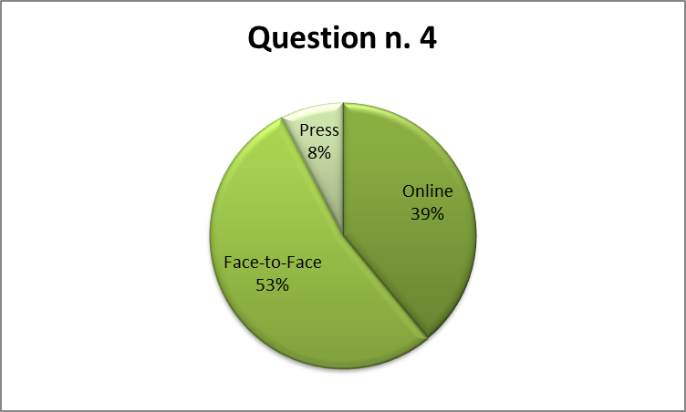

**Question 5:** Video is considered the most impactful media by the Italian responders; in general they are interested in contents available on the web (online) that are easily accessible through the smartphone:

* Video (17)
* Online (14)
* Mobile phones (12)
* Audio (3)
* Memory sticks (2)
* Press (0)

**Question 6:** According to the Italian responders, the technologies that would arouse their interest and motivate them better to learn about the NGEnvironment project and to make efficient use of its outcomes are the web-based technologies (16). But they also indicate as useful mobile technologies (11) and hypermedia/ multimedia technologies (10).

Considering 20 as total number of responders and that may have selected more than one option, Table 3 shows their preferences.

**Table 3: Technologies**

|  |  |  |
| --- | --- | --- |
| Technologies | | |
| Web-based technologies | 16 | 43% |
| Mobile technologies | 11 | 30% |
| [2]Hypermedia/multimedia technologies | 10 | 27% |
| Total answers | **37** |  |
| Total responders | **22** |  |

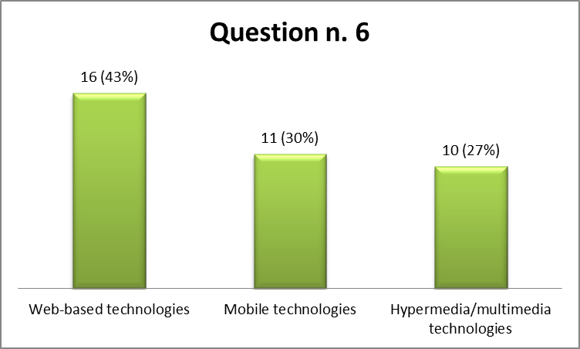

**Question 7:** Most part of responders (15=68%) would prefer to receive very structured (concise) information and with provided links for more details, 4 out of 22 (18%) prefer complete information, with all details at once, and only 3 (14%) prefersequential information (‘portions’ of information delivered one after the other, provided at different stages in project’s lifetime).

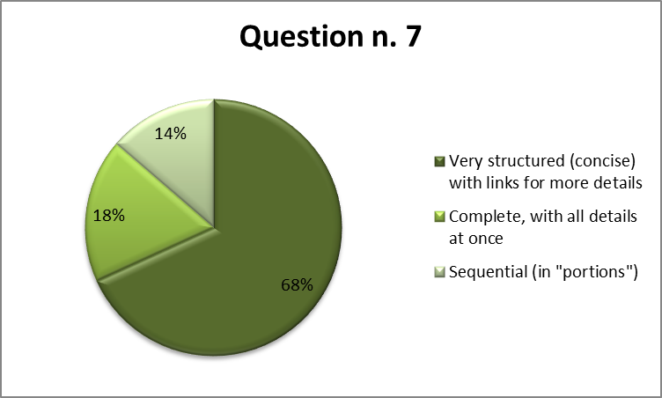

**Question 8:** Some respondents provided useful recommendations for the NGEnvironment consortium regarding the development of contents and materials to be included in the project’s Engagement Toolkit:

* Not too many emails but brief and clear periodic contents;
* Clarity on the objectives to be achieved, priority objectives, focus on few objectives at a time;
* Transparent technical-financial aspects;
* Insert something of visual impact to remember it more easily;
* The contents should be easily accessible and disclosable;
* Strong communication activities;
* Pay close attention to the accompanying reports;
* Useful info about crowdfunding, European tenders, local associations, social advertising strategies;
* Openness to selected specialist contribution forms.

# **Conclusions**

After analysing of the surveys’ results, it’s important to emphasise that men and women are quite equally represented (M=55% and F=45%) and of all the total 8 respondents (36%) are involved with NGOs for more than 5 years and other 8 (36%) are involved for less than 1 year (e.g. the younger respondents were the ones who referred that are involved for less years).

Please notice that we contacted some Italian young activists participating to the new movement “Fridays For Future[3]” founded and promoted by the Swedish 16 year old climate activist Greta Thunberg. The movement refers to strikes that every Friday are held to protest the lack of effective climate legislation on a governmental level. Thanks to Greta, students throughout Europe now regularly strike on Fridays.

In terms of the information that they intend to receive about NGOs and business-related, incentives and funding opportunities, best practices, useful links, legislation and supporting agencies are the main asked by the respondents. Regarding the materials, articles, newsletters, reports, guidelines and handbooks were on top of the most interested materials to receive.

In terms of the dissemination channels, it’s important to notice that most of the respondents said that face-to-face events would me more impactful (e.g. meetings, workshops and seminars). But also the online environments (e.g. online tools and contents available on mobile devices) are considered as useful channels thanks to their easy accessibility.

It also appeared to be a consensus in terms of how the information should be organised: 68% of the respondents preferred the very structured and concise scenario.

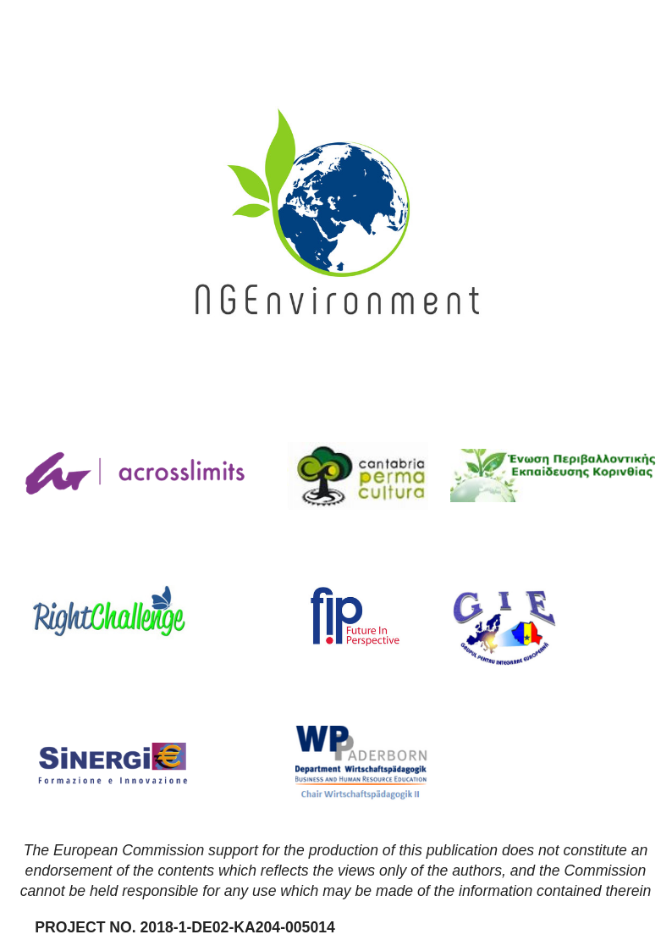

1. <https://www.tableau.com/>
2.
3. <https://www.fridaysforfuture.org/>