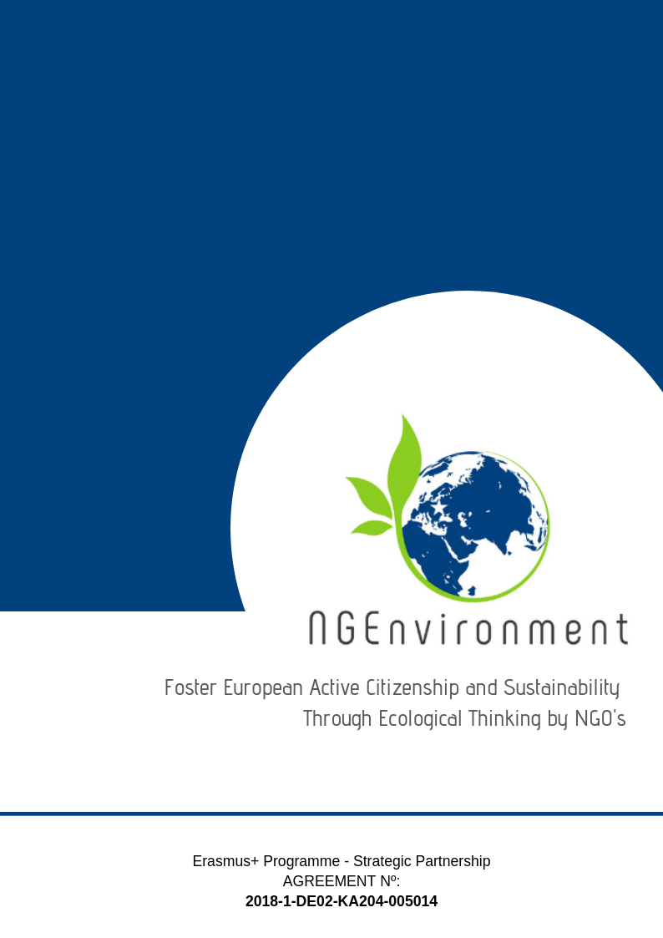­­­­­­­-­

IO5 – NATIONAL RESEARCH REPORT (Malta)

Acrosslimits Limited

# Heading 1 – Arial 18

Sample Heading

## Heading 2 – Arial 14

Sample Subtitle

Lorem ipsum dolor sit amet, consectetur adipiscing elit. Praesent id lectus tortor. Integer aliquam neque vel arcu scelerisque, non auctor metus efficitur. Aenean dolor enim, suscipit non tellus sit amet, posuere semper enim. Sed eu dolor turpis. Pellentesque maximus justo et est mattis, a pharetra ex convallis. Quisque nec risus eu metus ultricies semper. Duis eu velit vehicula ipsum egestas rhoncus id quis tellus. Curabitur rutrum nunc elit, a fringilla arcu facilisis vestibulum. Morbi convallis quam sit amet tellus convallis auctor. Mauris in dictum dui. Nulla vitae bibendum sem. Donec ut finibus tortor. Vestibulum ante ipsum primis in faucibus orci luctus et ultrices posuere cubilia Curae; Quisque quis enim id ex faucibus congue.

Suspendisse potenti. Nulla facilisi. Etiam efficitur enim eu velit interdum, eu egestas quam cursus. Sed dapibus, magna id facilisis rutrum, erat diam hendrerit ligula, id cursus felis orci eget sem. Donec efficitur mauris condimentum, mollis odio id, commodo elit. Praesent tempor pretium finibus. Sed id erat vitae metus tristique elementum.

Donec euismod ipsum non nisi sodales rhoncus. Sed ac velit hendrerit, eleifend nulla nec, faucibus mauris. Sed auctor magna vitae tortor fermentum, non dapibus nisi vulputate. Phasellus faucibus nulla nec feugiat ullamcorper. Praesent blandit faucibus dolor a ornare. Aliquam sit amet odio hendrerit dolor vulputate malesuada ac sit amet erat. Proin scelerisque vel elit ac dignissim. Praesent ullamcorper orci id dui porttitor malesuada. Ut sollicitudin, nisl dapibus molestie varius, nisi leo aliquam est, a semper tortor est nec erat. Praesent vel nisi lobortis, vehicula libero accumsan, bibendum diam. Nunc eu egestas risus. Donec dapibus elit diam, non pretium leo sagittis eu.

Lorem ipsum dolor sit amet, consectetur adipiscing elit. Praesent id lectus tortor. Integer aliquam neque vel arcu scelerisque, non auctor metus efficitur. Aenean dolor enim, suscipit non tellus sit amet, posuere semper enim. Sed eu dolor turpis. Pellentesque maximus justo et est mattis, a pharetra ex convallis. Quisque nec risus

**Table of Contents**

|  |  |  |
| --- | --- | --- |
|  | | **Page** |
|  | |  |
| 1. Introduction | | **2** |
| 1. Main findings | | **3** |
| 1. Conclusions | | **8** |
|  |
|  |

1. **Introduction**

This research report presents the findings from the research conducted by Acrosslimits regarding the development of the NG-Environment Engagement Toolkit (IO5). The methodology consisted of a research questionnaire distributed online to local NGOs, community groups and other activist groups in Malta. The following report provides a summary of the data collected from this research. In total, 20 questionnaires were distributed and 15 responded.

* 1. ***Sociodemographic profile of the respondents***

From the 15 respondents, 11 individuals provided their age in the questionnaire. From these 11 respondents, it was found that the ages range between 24 and 60 years.

All of the 15 respondents were female.

When asked to describe which research target group they were part of, the following roles and titles were mentioned:

* Staff and Leaders of Existing NGO (10)
* Potential NGO Leader (4)
* Social and Green Activist (1)

When asked about their length of experience in this sector, it was found to be as follows:

* Less than one year - 4
* Between 1 and 3 years - 2
* Between 3 and 5 years - 0
* Over 5 years – 9

1. **Main findings**

When asked about the kind of *information and dissemination materials actual/potential NGO or business were interested in*, respondents said that they would like to know more about:

**Table 1: *Types of informational materials interested in:***

|  |  |  |  |
| --- | --- | --- | --- |
| ***Type of materials*** | ***(N)*** | ***Type of materials*** | ***(N)*** |
| Best Practices | 8 | Political Decisions / Policies | 2 |
| Legislation | 6 | Women and Gender Issues | 1 |
| Incentives and funding opportunities | 6 | Success Factors | 2 |
| Useful links and networks for collaboration | 5 | Sources of profit | 1 |
| Statistics | 4 | Starting up an NGO – documentation and financial advice to create income to employ vulnerable clients | 1 |
| Supporting agencies/authorities | 3 | Research | 1 |
| Benefits | 2 | Training opportunities | 1 |
| Directives | 2 | Case Studies | 1 |
| Networking Events | 2 | Obstacles | 1 |

The above list is indicative of which topics NG-Environment partners should keep in mind when developing the resources for the Engagement Toolkit. It highlights main topics such as the need to share Best Practices, be informed about legislation as well as incentives and funding opportunities.

When asked what *type of dissemination materials* they would like this information to be presented in, our research participants gave the following answers:

**Table 2: *Types of informational materials accessed***

|  |  |  |  |
| --- | --- | --- | --- |
| ***Type of materials*** | ***(N)*** | ***Type of materials*** | ***(N)*** |
| Newsletters | 7 | Toolkits | 4 |
| Reports | 7 | Announcements | 4 |
| Leaflets | 6 | Flyers | 4 |
| Policy Papers | 6 | Advertisements | 3 |
| Statistics | 6 | Handbooks | 3 |
| Articles | 5 | Handouts | 3 |
| Newspapers | 5 | Online | 2 |
| Brochures | 5 | Posters | 1 |
| Books | 5 | Magazines | 1 |
| Guidelines | 5 | Social Media | 1 |
| Journals | 4 | Documentaries | 1 |
| Reviews | 4 |  |  |

The above indicates that respondents would prefer to access material through newsletters, leaflets, reports and statistics.

When asked about the materials *they would like to receive* about the NGEnvironment project, the following were mentioned:

**Table 3: *Materials about the NGEnvironment project***

|  |  |  |  |
| --- | --- | --- | --- |
| ***Materials*** | ***(N)*** | ***Materials*** | ***(N)*** |
| Guidelines | 3 | Background information about the project and its aims | 1 |
| Final Report | 3 | Emails | 1 |
| Project Updates | 3 | Online Support | 1 |
| Policy Papers | 2 | Training / Events from the Project | 1 |
| Toolkits | 2 | Announcements | 1 |
| No Answer | 2 | Online Articles | 1 |
| E-Newsletters | 1 | Reports | 1 |
| Videoclips | 1 | Statistics | 1 |

The *dissemination and advertising channels* presented in Table 4, shows no clear preference in relation to online environments, Seminars and Conferences for face-to-face channels and Written Presswhen it is about the press.

**Table 4: *Dissemination and advertising channels***

|  |  |  |  |  |  |
| --- | --- | --- | --- | --- | --- |
| ***Online*** | ***(N)*** | ***Face-to-face*** | ***(N)*** | ***Press*** | ***(N)*** |
| Social media | 13 | Conferences | 12 | Written Press | 11 |
| Emails | 13 | Workshops | 11 | TV | 6 |
| Websites | 11 | Seminars | 1 | Radio | 4 |
| Blogs | 2 | Round tables | 8 | No Answer | 1 |
| Skype, Zoom, Webex etc | 1 | Meetings | 6 |  |  |
|  |  | Info fairs | 2 |  |  |
|  |  | Thematic/specialised exhibitions | 2 |  |  |
|  |  | Information centres | 2 |  |  |
|  |  | Civic events | 2 |  |  |

Respondents were asked about the most impactful *support-media when it is about the NGEnvironment Engagement Toolkit.* Table 5 clearly shows a preference for online media.

**Table 5:** ***Most impactful support-media about the NGEnvironment Engagement Toolkit***

|  |  |  |  |
| --- | --- | --- | --- |
| ***Materials*** | ***(N)*** | ***Materials*** | ***(N)*** |
| Online | 11 | Mobile phones | 4 |
| Print | 6 | PC and PC-Tablets | 2 |
| Audio | 5 | CD-ROM | 2 |
| Video | 5 | Other: Email | 1 |
| Memory sticks | 3 |  |  |

Respondents were also asked about *technologies that would arouse the respondents’ interest and motivate them better to learn about the NGEnvironment project and to make efficient use of its outcomes*. As can be seen below, there is a clear preference for Web-Based Technologies.

**Table 6: *Most motivating technologies***

|  |  |  |  |
| --- | --- | --- | --- |
| ***Technologies*** | ***(N)*** | ***Materials*** | ***(N)*** |
| Web-Based | 13 | Multimedia | 5 |
| Mobile | 6 | Hyper | 1 |
|  |  |  |  |

Regarding how the respondents would like the provided information to be *structured / approached* within the materials that the NGEnvironment consortium will prepare for them and include in the project’s Engagement Toolkit, the responses are as below:

|  |  |
| --- | --- |
| ***Provision of Information*** | ***(N)*** |
| Very Structured / Concise | 6 |
| Complete Information | 2 |
| Sequential Information | 6 |
| Invalid Reply (2 chosen) | 1 |

Regarding any *necessary recommendations* for the NGEnvironment consortium regarding the development of contents and materials to be included in the project’s Engagement Toolkit, these are the responses given in the questionnaires:

* *Include the aspect of gender – to be gender mainstreamed*
* *It would be interesting to be provided information on how to use the project results in own organisation.*
* *Toolkit should take into consideration that the information could be availed of from multimedia such as online or mobile phone.*
* *It would be ideal for the toolkit to be user-friendly and easily accessible by people on the run – with podcasts being the ideal tool for people to learn on the move.*
* *It would be ideal for the contents and material to be easily accessible and written in a language that is easily understandable*

**Conclusions**

This research report presents the findings from the research conducted by Acrosslimits regarding the development of the NG-Environment Engagement Toolkit (IO5). It provides an overview of the main research findings from the responses gathered from 15 Maltese respondents. The respondents have a very wide age dispersion with ages ranging from 24 to 60. When it comes to gender, all respondents were female. The majority of respondents were already existing leaders and the majority also had 5+ years of experience.

The 3 highest response areas in relation to material respondents were interested in were in relation to Best Practices, Legislation and Funding opportunities. This is quite interesting when one considered that these 3 areas focus on growth because it helps NGOs learn how to function the best way possible, in a legal manner whilst having enough funds to continue to provide the service and achieve this level of good practice.

When asked about how this material can be disseminated, the majority mentioned Newsletters and Reports. This is quite interesting as it is a blend of short material combined with more detailed material. This shows that NGOs need ‘on-the-go’ information like newsletters but also require details in the form of reports.

When asked specifically about the NGEnvironment project and its materials, there was a balanced mix of replies including the Final Report, Project Updates and Guidelines.

In relation to advertising channels, it emerged clearly that NGOs today make use of all channels. There was a strong response in relation to online channels such as social media and emails. With regards face-face channels, conferences are the most sought after. In relation to traditional press, there was a strong preference to written channels.

Related to this, it emerged that the most impact support media in related to the NGEnvironment Engagement Toolkit was strongly indicated to be online and that web-based technologies would be the most motivating technologies to learn about the project.

Regarding how respondents would like to be kept updated with information, there was a tie between such information being either very structured or else sequential.

Not many respondents gave their recommendations but those who did mentioned the importance of the project being in an understandable language, user-friendly and easily applied in their organisation. It was also mentioned, in line with the findings, that the tool should be available in various media, including those for people ‘on-the-go’.

