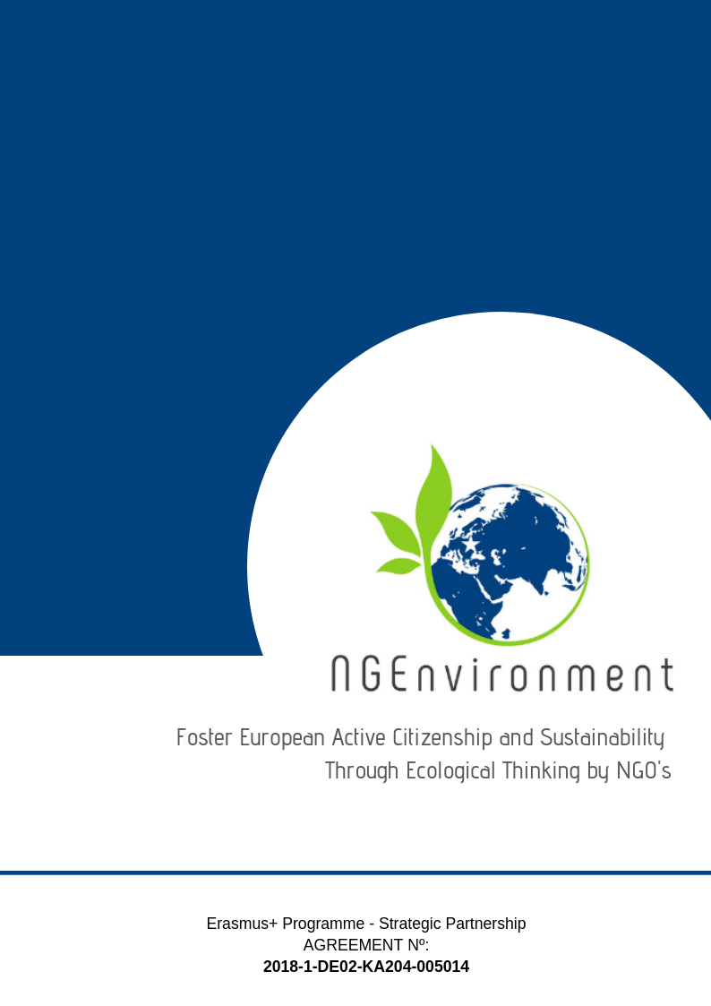­­­­­­­-­

IO5 – NATIONAL RESEARCH REPORT

Rightchallenge

# Heading 1 – Arial 18

Sample Heading

## Heading 2 – Arial 14

Sample Subtitle

Lorem ipsum dolor sit amet, consectetur adipiscing elit. Praesent id lectus tortor. Integer aliquam neque vel arcu scelerisque, non auctor metus efficitur. Aenean dolor enim, suscipit non tellus sit amet, posuere semper enim. Sed eu dolor turpis. Pellentesque maximus justo et est mattis, a pharetra ex convallis. Quisque nec risus eu metus ultricies semper. Duis eu velit vehicula ipsum egestas rhoncus id quis tellus. Curabitur rutrum nunc elit, a fringilla arcu facilisis vestibulum. Morbi convallis quam sit amet tellus convallis auctor. Mauris in dictum dui. Nulla vitae bibendum sem. Donec ut finibus tortor. Vestibulum ante ipsum primis in faucibus orci luctus et ultrices posuere cubilia Curae; Quisque quis enim id ex faucibus congue.

Suspendisse potenti. Nulla facilisi. Etiam efficitur enim eu velit interdum, eu egestas quam cursus. Sed dapibus, magna id facilisis rutrum, erat diam hendrerit ligula, id cursus felis orci eget sem. Donec efficitur mauris condimentum, mollis odio id, commodo elit. Praesent tempor pretium finibus. Sed id erat vitae metus tristique elementum.

Donec euismod ipsum non nisi sodales rhoncus. Sed ac velit hendrerit, eleifend nulla nec, faucibus mauris. Sed auctor magna vitae tortor fermentum, non dapibus nisi vulputate. Phasellus faucibus nulla nec feugiat ullamcorper. Praesent blandit faucibus dolor a ornare. Aliquam sit amet odio hendrerit dolor vulputate malesuada ac sit amet erat. Proin scelerisque vel elit ac dignissim. Praesent ullamcorper orci id dui porttitor malesuada. Ut sollicitudin, nisl dapibus molestie varius, nisi leo aliquam est, a semper tortor est nec erat. Praesent vel nisi lobortis, vehicula libero accumsan, bibendum diam. Nunc eu egestas risus. Donec dapibus elit diam, non pretium leo sagittis eu.

Lorem ipsum dolor sit amet, consectetur adipiscing elit. Praesent id lectus tortor. Integer aliquam neque vel arcu scelerisque, non auctor metus efficitur. Aenean dolor enim, suscipit non tellus sit amet, posuere semper enim. Sed eu dolor turpis. Pellentesque maximus justo et est mattis, a pharetra ex convallis. Quisque nec risus

**Table of Contents**

|  |  |  |
| --- | --- | --- |
|  | | **Page** |
|  | |  |
| 1. Introduction | | **2** |
| 1. Main findings | | **3** |
| 1. Conclusions | | **6** |
|  |
|  |

1. **Introduction**
   1. ***Sociodemographic profile of the respondents***

The Portuguese National Research Report presents 17 respondents between 23 and 60 years old who completed the questionnaire by e-mail. In terms of gender, 11 respondents are female and 6 are male.

**Chart 1: Age of the respondents**

According to chart 1, the Portuguese respondents are mainly young adults and adults. 7 respondents are between 23-33 years old and 10 respondents are between 35-60 years old.

**Chart 2: Category of the respondents**

Regarding the category, 7 of the respondents affirmed that they’re NGOs leaders and/or staff members, 5 said they are potential new NGO leaders and 5 are social and green activists.

**Chart 3: Duration in the NGO/Entrepreneurship field**

In terms of the length of experience and duration in the NGO/Entrepreneurship field, 7 respondents affirmed that they have more than 5 years of experience, 6 respondents said less than 1 year, 3 respondents enounced 1 to 3 years and only 1 respondent said 3 to 5 years

1. **Main findings**

**Chart 3: Information of interest**

When asked about the kind of information and dissemination materials that they are interested (Question 1), 13 respondents said that they want to know about the success factors and useful links, respectively. 10 respondents are interested in resources, 9 in the supporting agencies/authorities and the obstacles, 8 in risks, 6 in statistics, 5 in benefits, 4 in incentives and 1 in legislation.

|  |  |
| --- | --- |
| Materials of interest | (N=) |
| Articles | 13 |
| Policy papers | 11 |
| Reports | 11 |
| Toolkits | 8 |
| Handbooks | 8 |
| Brochures | 7 |
| Posters | 6 |
| Newsletters | 5 |
| Reviews | 5 |
| Books | 3 |
| Pens | 2 |
| Bags | 1 |
| USB sticks | 1 |

|  |  |
| --- | --- |
| Dissemination and advertising channels | (N=) |
| Websites | 14 |
| Emails | 13 |
| Social media | 13 |
| Blogs | 7 |
| Meetings | 7 |
| Workshops | 7 |
| Round tables | 7 |
| Info fairs | 5 |
| Conferences | 4 |
| Seminars | 4 |
| Thematic/specialized exhibitions | 4 |
| Information centres | 4 |
| Civic events | 4 |
| TV | 3 |
| Radio | 1 |
| Written press | 1 |

**Table 1: Materials of interest Table 2: Dissemination channels of interest**

Table 1 presents the materials of interest referred by the 17 Portuguese respondents. Articles (N=13), policy papers (N=11) and reports (N=11) were the most asked materials, followed by toolkits (N=8), handbooks, (N=8), brochures (N=7), posters, (N=6), newsletters (N=5), reviews (N=5), books (N=3), pens (N=2), bags (N=1) and USB sticks (N=1).

In terms of dissemination channels, table 2 shows that digital dissemination is the main preference of the Portuguese respondents: Websites (N=14), emails (N=13), social media (N=13) are the most preferred, followed by blogs (N=7), meetings (N=7)**,** workshops (N=7)**,** round tables (N=7), info fairs (N=5), conferences (N=4), seminars (N=4), thematic/specialized exhibitions (N=4), information centres (N=4), civic events (N=4), tv (N=3), radio (N=1) and written press (N=1).

**Chart 4: Engagement Toolkit support-media**

In terms of support-media that would me more impactful, 17 respondents enounced online environments, 15 said video and memory sticks respectively, 9 said mobile phones, 8 cd-room and 2 respondents enounced printed materials.

**Chart 5: Technologies of interest**

Regarding the technologies of interest, 11 respondents enounced that web-based technologies would be more impactful in terms of motivation, 9 enounced multimedia technologies, 4 said mobile technologies and only 1 respondent enounced hypermedia technologies.

**Chart 6: Structure of the information**

In terms of the information structure, 14 respondents enounced that they prefer the information very structure and with links provided for more details, 2 affirmed that they prefer the information complete and with all the details at once and 1 preferred sequential information.

1. **Conclusions**

After analysing of the surveys’ results, it’s important to emphasise that the respondents were mainly females (64,71%) and of all the total (N=17) respondents, 41,18% are involved with NGOs for more than 5 years, although 35,29% are involved for less than 1 year (e.g. the younger respondents were the ones who referred that are involved for less years).

In terms of the information that they intend to receive about NGOs and business-related, useful links, success stories, supporting agencies and resources are the main asked by the respondents. Regarding the materials, articles, policy papers and reports were on top of the most interested materials to receive.

In terms of the dissemination channels, it’s important to notice that most of the respondents said that the online environments would me more impactful (e.g. social media, websites and blogs). In fact, more than a half of the respondents enounced the websites (76,4%) as the most preferred dissemination channel.

Furthermore, the most preferred media-support was also online-based and digital (e.g. video, mobile phones), and the technology that would be more impactful in terms of motivation was also the web-based, with 64,71% of the total answers.

It also appeared to be a consensus in terms of how the information should be organised: 82,25% of the respondents preferred the very structured and concise scenario. Finally, no respondent answered the question related to the additional recommendations.

