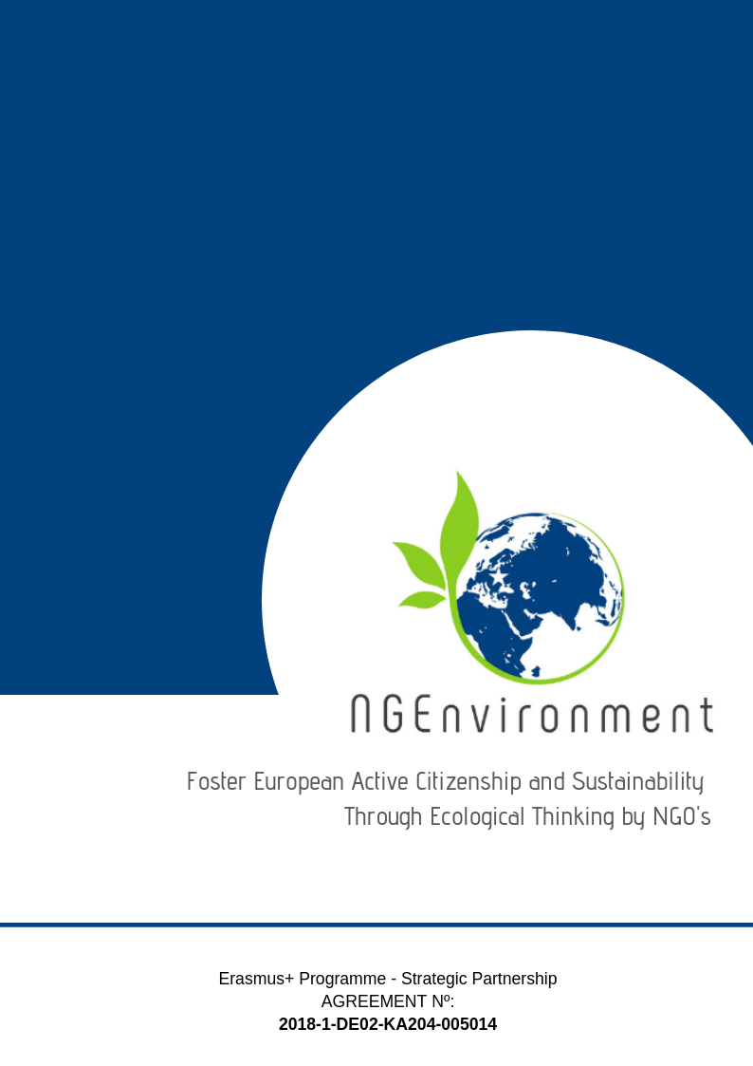­­­­­­­-­

IO5 – NATIONAL RESEARCH REPORT

Group for European Integration (GIE)

# Heading 1 – Arial 18

Sample Heading

## Heading 2 – Arial 14

Sample Subtitle

Lorem ipsum dolor sit amet, consectetur adipiscing elit. Praesent id lectus tortor. Integer aliquam neque vel arcu scelerisque, non auctor metus efficitur. Aenean dolor enim, suscipit non tellus sit amet, posuere semper enim. Sed eu dolor turpis. Pellentesque maximus justo et est mattis, a pharetra ex convallis. Quisque nec risus eu metus ultricies semper. Duis eu velit vehicula ipsum egestas rhoncus id quis tellus. Curabitur rutrum nunc elit, a fringilla arcu facilisis vestibulum. Morbi convallis quam sit amet tellus convallis auctor. Mauris in dictum dui. Nulla vitae bibendum sem. Donec ut finibus tortor. Vestibulum ante ipsum primis in faucibus orci luctus et ultrices posuere cubilia Curae; Quisque quis enim id ex faucibus congue.

Suspendisse potenti. Nulla facilisi. Etiam efficitur enim eu velit interdum, eu egestas quam cursus. Sed dapibus, magna id facilisis rutrum, erat diam hendrerit ligula, id cursus felis orci eget sem. Donec efficitur mauris condimentum, mollis odio id, commodo elit. Praesent tempor pretium finibus. Sed id erat vitae metus tristique elementum.

Donec euismod ipsum non nisi sodales rhoncus. Sed ac velit hendrerit, eleifend nulla nec, faucibus mauris. Sed auctor magna vitae tortor fermentum, non dapibus nisi vulputate. Phasellus faucibus nulla nec feugiat ullamcorper. Praesent blandit faucibus dolor a ornare. Aliquam sit amet odio hendrerit dolor vulputate malesuada ac sit amet erat. Proin scelerisque vel elit ac dignissim. Praesent ullamcorper orci id dui porttitor malesuada. Ut sollicitudin, nisl dapibus molestie varius, nisi leo aliquam est, a semper tortor est nec erat. Praesent vel nisi lobortis, vehicula libero accumsan, bibendum diam. Nunc eu egestas risus. Donec dapibus elit diam, non pretium leo sagittis eu.

Lorem ipsum dolor sit amet, consectetur adipiscing elit. Praesent id lectus tortor. Integer aliquam neque vel arcu scelerisque, non auctor metus efficitur. Aenean dolor enim, suscipit non tellus sit amet, posuere semper enim. Sed eu dolor turpis. Pellentesque maximus justo et est mattis, a pharetra ex convallis. Quisque nec risus

**Table of Contents**

|  |  |  |
| --- | --- | --- |
|  | | **Page** |
|  | |  |
| 1. Introduction | | **2** |
| 1. Main findings | | **3** |
| 1. Conclusions | | **6** |
|  |
|  |

1. **Introduction**

The Group for European Integration (GIE) has implemented the research in Pitești city and the Argeș region. It has applied the research questionnaire to 24 persons of the target groups and it has got back 21 filled in questionnaires. The questionnaires have been applied face-to-face (11 persons) and by email (13 persons).

The research was achieved in the period 31st of March to 26th of April 2019.

The profile of the respondents is presented in Table 1 below.

**Table 1: *Respondents’ profile***

|  |  |  |  |  |  |  |  |  |  |
| --- | --- | --- | --- | --- | --- | --- | --- | --- | --- |
|  |  |  | ***Category*** | | | ***Duration (in years) since activates in the NGO and/or entrepreneurial field*** | | | |
|  | ***Age (years)*** | ***Gender*** | ***1 - potential new NGO leaders*** | ***2 - existing NGO leaders and staff members*** | ***3 - social and green activists*** | ***less than 1 year*** | ***1 to 3 years*** | ***3 to 5 years*** | ***over 5 years*** |
| 1 | 21 | F |  |  | x |  |  |  | x |
| 2 | 20 | F |  |  | x |  | x |  |  |
| 3 | 20 | F |  |  | x |  | x |  |  |
| 4 | 21 | F | x |  |  |  | x |  |  |
| 5 | - | F | x |  |  | x |  |  |  |
| 6 | - | M | x |  |  | x |  |  |  |
| 7 | - | M | x |  |  |  | x |  |  |
| 8 | 28 | F | x |  |  | x |  |  |  |
| 9 | - | F | x |  |  | x |  |  |  |
| 10 | 20 | F | x |  |  | x |  |  |  |
| 11 | 21 | F |  |  | x | x |  |  |  |
| 12 | 58 | F |  | x |  |  |  |  | x |
| 13 | 44 | F |  | x |  |  |  |  | x |
| 14 | 40 | F |  | x |  |  |  |  | x |
| 15 | 60 | F |  | x |  |  |  |  | x |
| 16 | 46 | M |  | x |  |  |  |  | x |
| 17 | - | F |  | x |  |  | x |  |  |
| 18 | 55 | F |  | x |  |  |  |  | x |
| 19 | - | M |  | x |  |  |  | x |  |
| 20 | - | M |  | x |  |  |  | x |  |
| 21 | - | F |  | x |  |  | x |  |  |
| **Total** | | | **7** | **10** | **4** | **6** | **6** | **2** | **7** |

The data in the table above provided the following statistics:

* the age range of the respondents spans from 20 to 60 years, with an average of 34.9 years;
* the gender distribution among respondents was: 5 persons were men (23.8%) and 16 persons were women (76.2%);
* the split of the respondents in envisaged categories was: 33.3% potential new NGO leaders, 47.6% existing NGO leaders and staff members and 19.1% social and green activists;
* 28.5% of the respondents have less than 1-year experience in the NGO and/or entrepreneurial field, 28.5% an experience from 1 to 3 years, 9.5% from 3 to 5 years and 33.5% over 5 years of such experience.

1. **Main findings**

When asked about ***what kind of information and dissemination materials they are interested to receive regarding your actual/potential NGO or business, though various informational and dissemination materials*** (Question 1), the answers displayed a quite large variety of such materials, as shown in Table 2.

**Table 2:** ***Information and materials of interest***

|  |  |  |  |  |  |
| --- | --- | --- | --- | --- | --- |
| ***Information and materials of interest*** | ***(N)*** | ***%*** | ***Information and materials of interest*** | ***(N)*** | ***%*** |
| Legislation for NGOs and regarding volunteering and how to implement this issue correctly | 13 | 61.9 | Active or future projects | 2 | 9.5 |
| Success factors (for NGOs and active citizenship) | 9 | 42.8 | Incentives | 1 | 4.7 |
| Examples of good practices | 7 | 33.3 | Profits | 1 | 4.7 |
| Useful links (i.e. for NGO field and entrepreneurial environment, about ongoing projects in the online environment) | 5 | 23.8 | Newsletters | 1 | 4.7 |
| Risks (for sustainability of NGOs) | 5 | 23.8 | Flyers | 1 | 4.7 |
| Statistics | 5 | 23.8 | Case studies | 1 | 4.7 |
| Resources and support materials for NGO activities and NGO ecological thinking | 4 | 19 | Events | 1 | 4.7 |
| Supporting agencies/authorities for environmental and social NGOs | 4 | 19 | Funding opportunities | 1 | 4.7 |
| Benefits | 3 | 14.2 | Partnerships | 1 | 4.7 |
| Obstacles | 3 | 14.2 | Contacts with other NGOs | 1 | 4.7 |

As one can see from Table 2 above, *legislative aspects*, *success fa*ctors and *useful links* are considered as being the most important for NGO leaders.

The question about ***types of materials the respondents usually access (have access to) for getting information and news within the NGO field and entrepreneurial environment*** (Question 2) revealed that the project target groups use all types of existing informational materials, with the most preferred being the *flyers, brochures* and *articles* on topics of interest, as shown by Table 3.

**Table 3: *Types of informational materials accessed***

|  |  |  |  |  |  |
| --- | --- | --- | --- | --- | --- |
| ***Type of materials*** | ***(N)*** | ***%*** | ***Type of materials*** | ***(N)*** | ***%*** |
| Flyers | 11 | 52.3 | Advertisements | 5 | 23.8 |
| Brochures | 10 | 47.6 | Journals | 4 | 19 |
| Articles | 9 | 42.8 | Newspapers (ordinary or specialised) | 3 | 14.2 |
| Statistics | 8 | 38 | Curricula | 3 | 14.2 |
| Magazines | 8 | 38 | Books | 3 | 14.2 |
| Guidelines | 8 | 38 | Announcements | 3 | 14.2 |
| Newsletters | 7 | 33.3 | Leaflets | 2 | 9.5 |
| Reports | 6 | 28.5 | Handbooks | 1 | 4.7 |
| Policy papers | 5 | 23.8 | Toolkits | 1 | 4.7 |
| Posters | 5 | 23.8 | Handouts | 1 | 4.7 |
| Reviews | 5 | 23.8 | Other: online documents, specialised websites ([www.fonduristructurale.ro](http://www.fonduristructurale.ro) [www.stiri.ong](http://www.stiri.ong) , etc.), Internet, websites of the financers | 1 | 4.7 |

When asked about ***what kind of materials they would like to receive*** ***about the NGEnvironment project and its outcomes*** (Question 3) the respondents listed various types of materials as shown in Table 4 below with (i) *good practices guide and guidelines, (ii) books* and *(iii) brochures* on top, but have been also very specific in indicating their interests, namely: *project results; invitation to events; sources, resources and support materials; any material about NGO-specific legislation, grants, successful projects, good practices, etc. - preferably in electronic format; newsletters, statistics, project toolkit and curriculum, project objectives, partners, future projects; materials on acquiring entrepreneurial skills and encouraging employability, socio-educational and professional development; Applicant's Guide, Calls for Selection, dissemination of results.*

**Table 4: *Materials about the NGEnvironment project***

|  |  |  |  |  |  |
| --- | --- | --- | --- | --- | --- |
| ***Materials*** | ***(N)*** | ***%*** | ***Materials*** | ***(N)*** | ***%*** |
| Good practices guide and guidelines | 7 | 33.3 | Flyers | 2 | 9.5 |
| Books | 4 | 19 | Handbooks | 2 | 9.5 |
| Brochures | 3 | 14.2 | Magazines | 2 | 4.7 |
| Reviews | 3 | 14.2 | Articles | 1 | 4.7 |
| Reports | 3 | 14.2 | Posters | 1 | 4.7 |

The ***dissemination and advertising channels*** (Question 4) are presented in Table 5, with the most preferred being, per category, (i) *social media* for online environments, (ii) *meetings* and *seminars* for face-to-face channels and (iii) *TV* when it is about the press.

**Table 5: *Dissemination and advertising channels***

|  |  |  |  |  |  |  |  |  |
| --- | --- | --- | --- | --- | --- | --- | --- | --- |
| ***Online*** | ***(N)*** | ***%*** | ***Face-to-face*** | ***(N)*** | ***%*** | ***Press*** | ***(N)*** | ***%*** |
| Social media (Facebook, Twitter, WhatsApp, Instagram, etc.) | 18 | 85.7 | Meetings | 16 | 76.1 | TV | 13 | 61.9 |
| Emails | 17 | 80.9 | Seminars | 16 | 76.1 | Written press | 8 | 23.8 |
| Websites | 15 | 71.4 | Workshops | 12 | 57.1 | Radio | 4 | 19 |
| Blogs | 8 | 38.1 | Round tables | 10 | 47.6 | Other: press conference, online press | 1 | 4.7 |
| Skype, Zoom, WEBex, etc. | 5 | 23.8 | Conferences | 9 | 42.8 |  |  |  |
|  |  |  | Info fairs | 9 | 42.8 |  |  |  |
|  |  |  | Thematic/specialised exhibitions | 8 | 23.8 |  |  |  |
|  |  |  | Information centres | 8 | 23.8 |  |  |  |
|  |  |  | Civic events (peaceful marches, demonstrations, etc.) | 7 | 33.3 |  |  |  |

The most impactful ***support-media when it is about the NGEnvironment Engagement Toolkit*** (Question 5)are the *video* and *online* media, according to our respondents’ opinion, as displayed in Table 6 below.

**Table 6: *Most impactful support-media about the NGEnvironment Engagement Toolkit***

|  |  |  |  |  |  |
| --- | --- | --- | --- | --- | --- |
| ***Materials*** | ***(N)*** | ***%*** | ***Materials*** | ***(N)*** | ***%*** |
| Video | 14 | 66.6 | Mobile phones | 8 | 38.1 |
| Online | 12 | 57.1 | PC and PC-Tablets | 7 | 33.3 |
| Audio | 9 | 42.8 | Print | 6 | 28.5 |
| Memory sticks | 9 | 42.8 | CD-ROM | 3 | 14.2 |

In terms of ***technologies that would arouse the respondents’ interest and motivate them better to learn about the NGEnvironment project and to make efficient use of its outcomes*** (Question 6), the *web-based technologies* and the *mobile technologies* have recorded the highest scores with 61.9% each (N = 13), followed by *multimedia technologies* (N = 6, 28.5%) and *hypermedia technology* (N = 5, 23.8%).

Regarding ***how they would like the provided information to be structured / approached within the materials that the NGEnvironment consortium will prepare for them and include in the project’s Engagement Toolkit*** (Question 7), the majority of the respondents would appreciate *a very structured (concise) information and with provided links for more details* (N = 16, 76.2%), while only reduced percentages of NGOs leaders would prefer *complete information, with all details at once* (N = 4, 19%) or *sequential information (‘portions’ of information delivered one after the other, provided at different stages in project’s lifetime)* (N = 1, 4.8%).

Regarding ***any necessary recommendations for the NGEnvironment consortium regarding the development of contents and materials to be included in the project’s Engagement Toolkit*** (Question 8), we got only few but relevant answers:

* *Give concrete results, procedures and methodologies, as well as applications;*
* *How can Ecological Thinking be used for involving actively the citizens in the sustainable development;*
* *I believe the project has enough informational materials that everyone understands;*
* *More information on the project.*

1. **Conclusions**

From interpreting the findings of our research, we may conclude the following:

The Romanian project target groups are interested to get information and materials for the field of NGO or business upon specific issues like legislation for NGOs, volunteering and how to implement volunteering correctly, success factors for NGOs and active citizenship and also examples of good practices.

The most accessed by them types of informational materials are: the flyers, brochures and articles. And again, good practices guide & guidelines are mentioned as first preference when it is about receiving materials about the NGEnvironment project and its outcomes, which makes a good coherence with what kind of materials our target groups generally use/access, providing in the same time, to NGEnvironment consortium a good indication on what kind of materials we should prepare for the project Engagement Toolkit.

Social media, emails, websites, meetings & seminars and TV channels are the dissemination and advertising channels that NGEnvironment should use, in order to fit the preferences of the Romanian target groups. We have to emphasize here that the social media got a very high score (85.7%), making it clear in front of the other categories.

Based on the obtained scores, video and online media proved to be a ‘must’ for the NGEnvironment Engagement Toolkit, so our consortium should take them into account, as well as web-based and multimedia technologies.

Clearly, the NGEnvironment Engagement Toolkit should provide information in a very structured (concise) approach and with given links for more details, as this approach was preferred by the majority of our respondents.

As recommended by one of the respondents, an important aspect to be considered by our consortium when designing the NGEnvironment Engagement Toolkit is that we should include also information on how can Ecological Thinking be used for involving actively the citizens in the sustainable development.

***One above the other, we appreciate that the findings from our research reveal that the way in which the project partners have thought and sketched already the envisaged components of the NGEnvironment Engagement Toolkit fit very well the target groups needs and preferences, and there is a very good match between the toolkit features and the research findings.***

