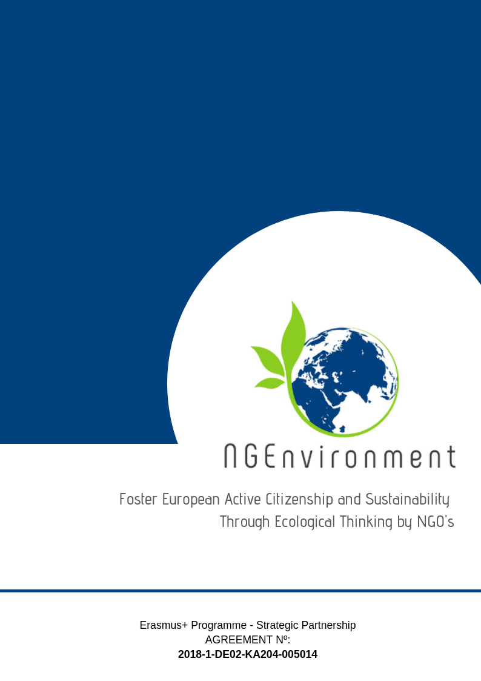­­­­­­­-­

IO5 – NATIONAL RESEARCH REPORT

Permacultura

Cantabria (Spain)

# Heading 1 – Arial 18

Sample Heading

## Heading 2 – Arial 14

Sample Subtitle

Lorem ipsum dolor sit amet, consectetur adipiscing elit. Praesent id lectus tortor. Integer aliquam neque vel arcu scelerisque, non auctor metus efficitur. Aenean dolor enim, suscipit non tellus sit amet, posuere semper enim. Sed eu dolor turpis. Pellentesque maximus justo et est mattis, a pharetra ex convallis. Quisque nec risus eu metus ultricies semper. Duis eu velit vehicula ipsum egestas rhoncus id quis tellus. Curabitur rutrum nunc elit, a fringilla arcu facilisis vestibulum. Morbi convallis quam sit amet tellus convallis auctor. Mauris in dictum dui. Nulla vitae bibendum sem. Donec ut finibus tortor. Vestibulum ante ipsum primis in faucibus orci luctus et ultrices posuere cubilia Curae; Quisque quis enim id ex faucibus congue.

Suspendisse potenti. Nulla facilisi. Etiam efficitur enim eu velit interdum, eu egestas quam cursus. Sed dapibus, magna id facilisis rutrum, erat diam hendrerit ligula, id cursus felis orci eget sem. Donec efficitur mauris condimentum, mollis odio id, commodo elit. Praesent tempor pretium finibus. Sed id erat vitae metus tristique elementum.

Donec euismod ipsum non nisi sodales rhoncus. Sed ac velit hendrerit, eleifend nulla nec, faucibus mauris. Sed auctor magna vitae tortor fermentum, non dapibus nisi vulputate. Phasellus faucibus nulla nec feugiat ullamcorper. Praesent blandit faucibus dolor a ornare. Aliquam sit amet odio hendrerit dolor vulputate malesuada ac sit amet erat. Proin scelerisque vel elit ac dignissim. Praesent ullamcorper orci id dui porttitor malesuada. Ut sollicitudin, nisl dapibus molestie varius, nisi leo aliquam est, a semper tortor est nec erat. Praesent vel nisi lobortis, vehicula libero accumsan, bibendum diam. Nunc eu egestas risus. Donec dapibus elit diam, non pretium leo sagittis eu.

Lorem ipsum dolor sit amet, consectetur adipiscing elit. Praesent id lectus tortor. Integer aliquam neque vel arcu scelerisque, non auctor metus efficitur. Aenean dolor enim, suscipit non tellus sit amet, posuere semper enim. Sed eu dolor turpis. Pellentesque maximus justo et est mattis, a pharetra ex convallis. Quisque nec risus

**Table of Contents**

|  |  |  |
| --- | --- | --- |
|  | | **Page** |
|  | |  |
| 1. Introduction | | **2** |
| 1. Main findings | | **3** |
| 1. Conclusions | | **8** |
|  |
|  |

1. **Introduction**

The NGO Permacultura Cantabria has implemented the research in the Autonomous Community of Cantabria and Madrid. The research questionnaire was filled out by 24 persons of the target groups. A Google survey has been sent by WhatsApp to our regional network (15 responses), applied by phone (5 responses) and it was also published in our social networks (4 responses). The research was conducted in the period 7th to 12nd of May 2019.

The profile of the respondents is presented in Table 1 below.

**Table 1: *Respondents’ profile***

|  |  |  |  |  |  |  |  |  |  |
| --- | --- | --- | --- | --- | --- | --- | --- | --- | --- |
|  |  |  | ***Category*** | | | ***Duration (in years) since activates in the NGO and/or entrepreneurial field*** | | | |
|  | ***Age (years)*** | ***Gender*** | ***1 - potential new NGO leaders*** | ***2 - existing NGO leaders and staff members*** | ***3 - social and green activists*** | ***less than 1 year*** | ***1 to 3 years*** | ***3 to 5 years*** | ***over 5 years*** |
| 1 | 38 | Female | x |  |  |  |  |  | x |
| 2 | 39 | Male |  | x |  |  |  |  | x |
| 3 | 37 | Female |  | x |  |  | x |  |  |
| 4 | 37 | Male |  | x |  |  |  |  | x |
| 5 | 37 | Female |  | x |  |  |  |  | x |
| 6 | 30 | Male |  | x |  |  | x |  |  |
| 7 | 37 | Female |  | x |  |  |  |  | x |
| 8 | 33 | Female | x |  |  |  |  | x |  |
| 9 |  | Male |  |  | x |  | x |  |  |
| 10 |  | Female |  |  | x |  |  |  | x |
| 11 | 41 | Female |  |  | x |  |  |  | x |
| 12 |  | Female |  |  | x |  |  |  | x |
| 13 | 23 | Female | x |  |  | x |  |  |  |
| 14 | 28 | Female | x |  |  | x |  |  |  |
| 15 | 20 | Male | x |  |  |  | x |  |  |
| 16 | 37 | Male |  |  | x |  |  |  | x |
| 17 | 39 | Female | x |  |  | x |  |  |  |
| 18 | 26 | Male |  |  | x | x |  |  | x |
| 19 |  | Male |  | x |  |  |  | x |  |
| 20 | 49 | Male |  |  | x |  |  |  | x |
| 21 | 37 | Female |  | x |  |  |  |  | x |
| 22 | 25 | Female |  |  | x |  |  | x |  |
| 23 | 39 | Female |  |  | x |  |  |  | x |
| 24 | 23 | Female |  |  | x |  | x |  |  |
| **Total** | | | **6** | **8** | **10** | **4** | **5** | **3** | **12** |

The data in the table above provided the following statistics:

* the age range of the respondents spans from 20 to 49 years, with an average of 32,1 years and a median of 37 years;
* the gender distribution among respondents was: 9 persons were men (37.5%) and 15 persons were women (62.5%);
* the split of the respondents in envisaged categories was: 25% potential new NGO leaders, 33,33% existing NGO leaders and staff members and 41,67% social and green activists;
* 16,66% of the respondents have less than 1-year experience in the NGO and/or entrepreneurial field, 20,83% an experience from 1 to 3 years, 12.5% from 3 to 5 years and 50% over 5 years of such experience.

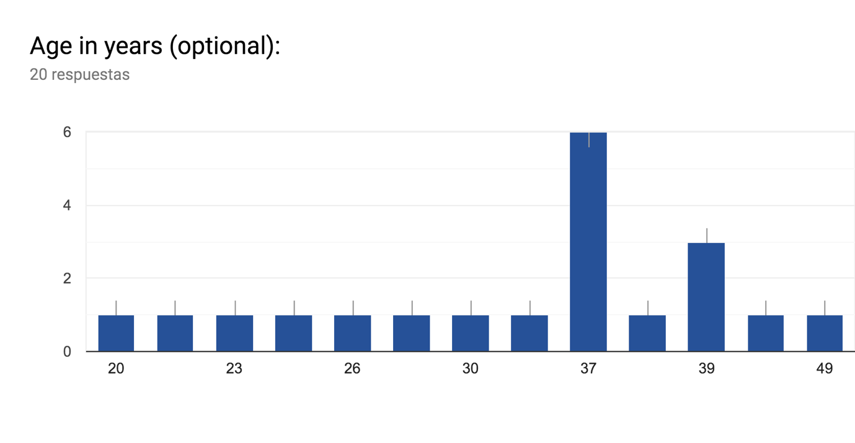

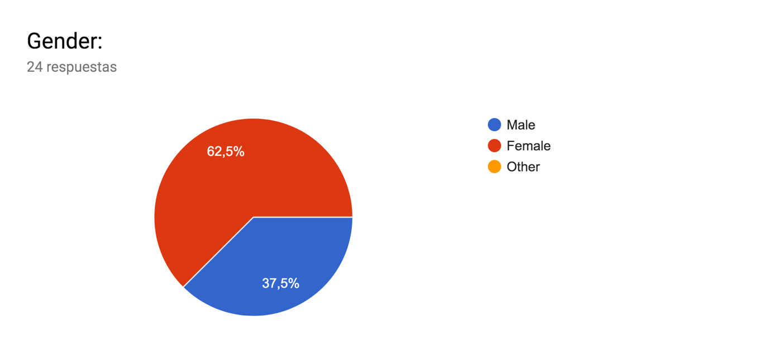

1. **Main findings**

When asked about ***what kind of information and dissemination materials they are interested to receive regarding your actual/potential NGO or business, though various informational and dissemination materials*** (Question 1), the answers displayed a quite large variety of such materials, as shown in Table 2.

**Table 2:** ***Information and materials of interest***

|  |  |  |  |  |  |
| --- | --- | --- | --- | --- | --- |
| ***Information and materials of interest*** | ***(N)*** | ***%*** | ***Information and materials of interest*** | ***(N)*** | ***%*** |
| Examples of good practices/testimonies | 10 | 14,93 | Risks (for sustainability of NGOs) | 3 | 4,48 |
| Resources (innovation, creativity, tools, methodologies, software) | 9 | 13,43 | Funding opportunities and information | 3 | 4,48 |
| Useful links | 7 | 10,45 | Statistics and scientific data | 3 | 4,48 |
| Incentives | 6 | 8,96 | Profits | 2 | 2,99 |
| Legislation | 5 | 7,46 | Case studies | 1 | 1,49 |
| Success factors | 4 | 5,97 | Events | 1 | 1,49 |
| Networking opportunities | 3 | 4,48 | Active or future projects | 1 | 1,49 |
| Supporting agencies/authorities for environmental and social NGOs | 3 | 4,48 |  |  |  |
| Benefits | 3 | 4,48 |  |  |  |
| Obstacles | 3 | 4,48 |  |  |  |

As showed on Table 2 good practices, resources, links and incentives are considered as being the most important for the third sector respondents.

The question about ***types of materials the respondents usually access (have access to) for getting information and news within the NGO field and entrepreneurial environment*** (Question 2) revealed that the project target groups use all types of existing informational materials, with the most preferred being the *articles, newsletters, books and magazines* on topics of interest, as shown by Table 3.

**Table 3: *Types of informational materials accessed***

|  |  |  |  |  |  |
| --- | --- | --- | --- | --- | --- |
| ***Type of materials*** | ***(N)*** | ***%*** | ***Type of materials*** | ***(N)*** | ***%*** |
| Flyers | 4 | 3,2 | Brochures | 5 | 4 |
| Newsletters | 18 | 14,4 | Handbooks | 2 | 1,6 |
| Toolkits | 3 | 2,4 | Policy papers | 4 | 3,2 |
| Statistics | 4 | 3,2 | Journals | 4 | 3,2 |
| Magazines | 10 | 8 | Announcements | 7 | 5,6 |
| Newspapers (ordinary or specialised) | 6 | 4,8 | Posters | 6 | 4,8 |
| Leaflets | 3 | 2,4 | handouts | 2 | 1,6 |
| Guidelines | 2 | 1,6 | Reports | 8 | 6,4 |
| Curricula | 1 | 0,8 | Reviews | 6 | 4,8 |
| Books | 11 | 8,8 | Advertisements | 0 | 0 |
| Articles | 18 | 14,4 | Other: specific information | 1 | 0,8 |

When asked about ***what kind of materials they would like to receive*** ***about the NGEnvironment project and its outcomes*** (Question 3) the respondents listed the materials listed above*.*

**Table 4: *Materials about the NGEnvironment project***

|  |  |  |  |  |  |
| --- | --- | --- | --- | --- | --- |
| ***Materials*** | ***(N)*** | ***%*** | ***Materials*** | ***(N)*** | ***%*** |
| Magazines/Journals | 5 | 13,89 | Mailing list | 2 | 5,56 |
| Articles | 5 | 13,89 | Toolkit | 2 | 5,56 |
| Newsletters | 4 | 11,11 | Posters | 2 | 5,56 |
| Books | 3 | 8,33 | Announcements | 1 | 2,77 |
| Reports/Summaries | 3 | 8,33 | Policy papers | 1 | 2,77 |

Other answers provided: Digested scientific information, NGO networks out of wealthy Europe, Tipps, Success examples, Resources, Videos, Training. The ones I can read on the go.

The ***dissemination and advertising channels*** (Question 4) are presented in Table 5, with the most preferred being, per category, (i) *social media*, emails and websites for online environments, (ii) workshops, *meetings* and *conferences* for face-to-face channels and (iii) *written press* when it is about the press.

**Table 5: *Dissemination and advertising channels***

|  |  |  |  |  |  |  |  |  |
| --- | --- | --- | --- | --- | --- | --- | --- | --- |
| ***Online*** | ***(N)*** | ***%*** | ***Face-to-face*** | ***(N)*** | ***%*** | ***Press*** | ***(N)*** | ***%*** |
| Social media (Facebook, Twitter, WhatsApp, Instagram, etc.) | 18 | 14,63 | Workshops | 11 | 8,94 | Written press | 3 | 2,44 |
| Emails | 17 | 13,82 | Meetings | 10 | 8,13 | Radio | 2 | 1,63 |
| Websites | 12 | 9,76 | Conferences | 10 | 8,13 | Other: Webinars (online trainings), Telegram channel | 2 | 1,63 |
| Blogs | 5 | 4,07 | Seminars | 6 | 4,88 | TV | 1 | 0,81 |
| Skye, Zoom, etc | 3 | 2,44 | Thematic/specialised exhibitions | 6 | 4,88 |  |  |  |
|  |  |  | Civic events (peaceful marches, demonstrations, etc.) | 6 | 4,88 |  |  |  |
|  |  |  | Round tables | 5 | 4,07 |  |  |  |
|  |  |  | Info fairs | 3 | 2,44 |  |  |  |
|  |  |  | Information centres | 3 | 2,44 |  |  |  |

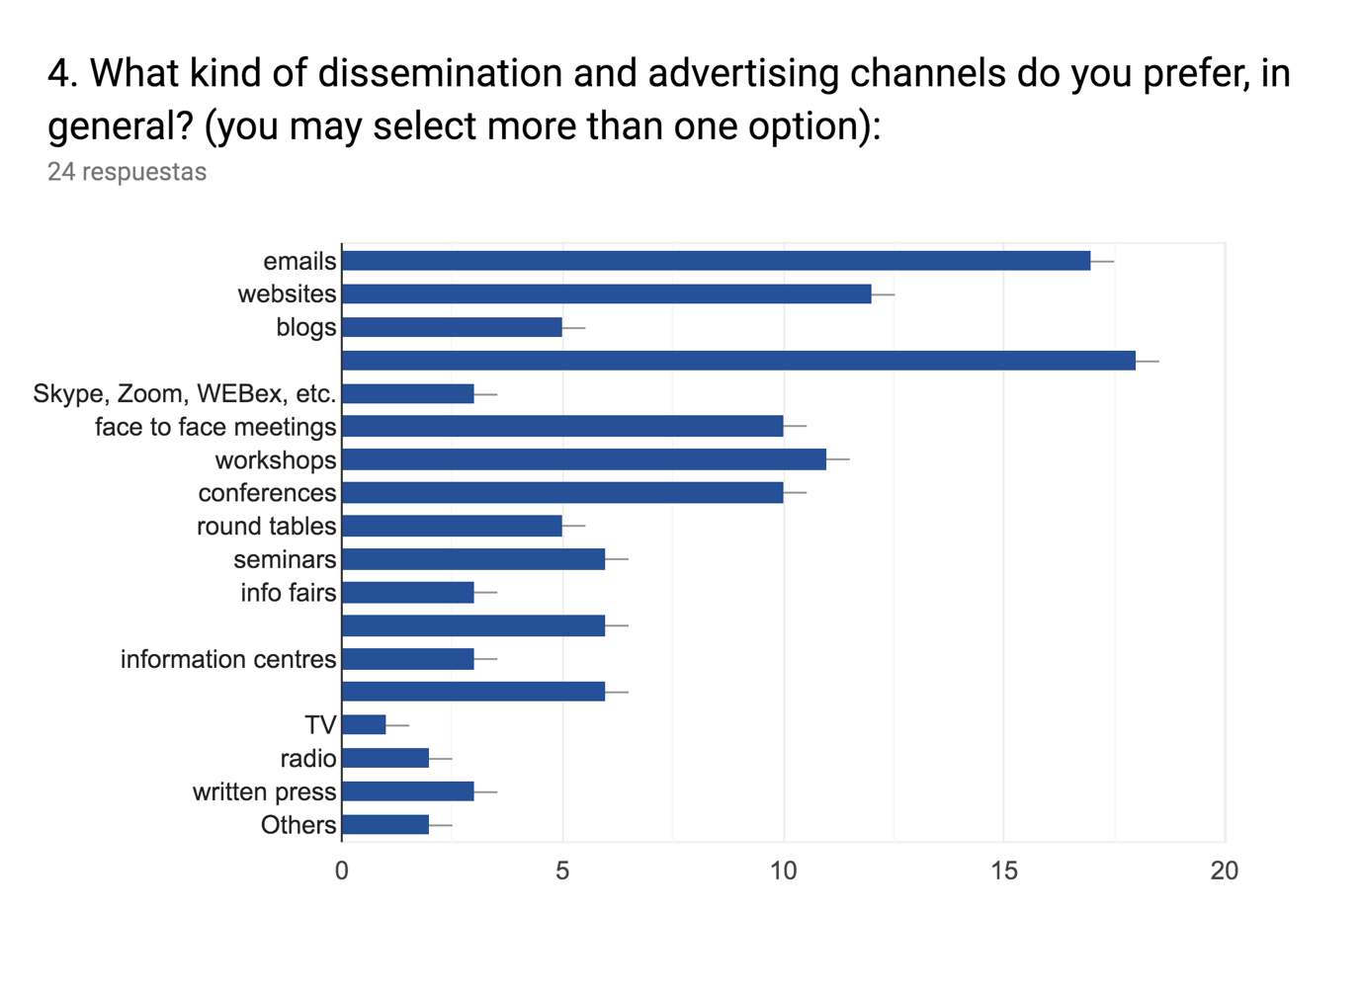

The most impactful ***support-media when it is about the NGEnvironment Engagement Toolkit*** (Question 5)are the *video* and *mobile phones*, according to our respondents’ opinion, as displayed in Table 6 below.

**Table 6: *Most impactful support-media about the NGEnvironment Engagement Toolkit***

|  |  |  |  |  |  |
| --- | --- | --- | --- | --- | --- |
| ***Materials*** | ***(N)*** | ***%*** | ***Materials*** | ***(N)*** | ***%*** |
| Video | 20 | 41,67 | Memory sticks | 3 | 6,25 |
| Mobile phones | 11 | 22,92 | Print | 2 | 4,17 |
| PC and PC-Tablets | 6 | 12,50 | CD-ROM | 0 | 0 |
| Audio | 5 | 10,42 | Others (podcast) | 1 | 2,08 |

In terms of ***technologies that would arouse the respondents’ interest and motivate them better to learn about the NGEnvironment project and to make efficient use of its outcomes*** (Question 6), the *mobile technologies* (N=17 corresponding to the 37,78%) and the *web-based technologies* (N=11; 24,44%) have recorded the highest scores, followed by *multimedia technologies* (N = 9; 20%) and *hypermedia technology* (N = 8, 17,78%).

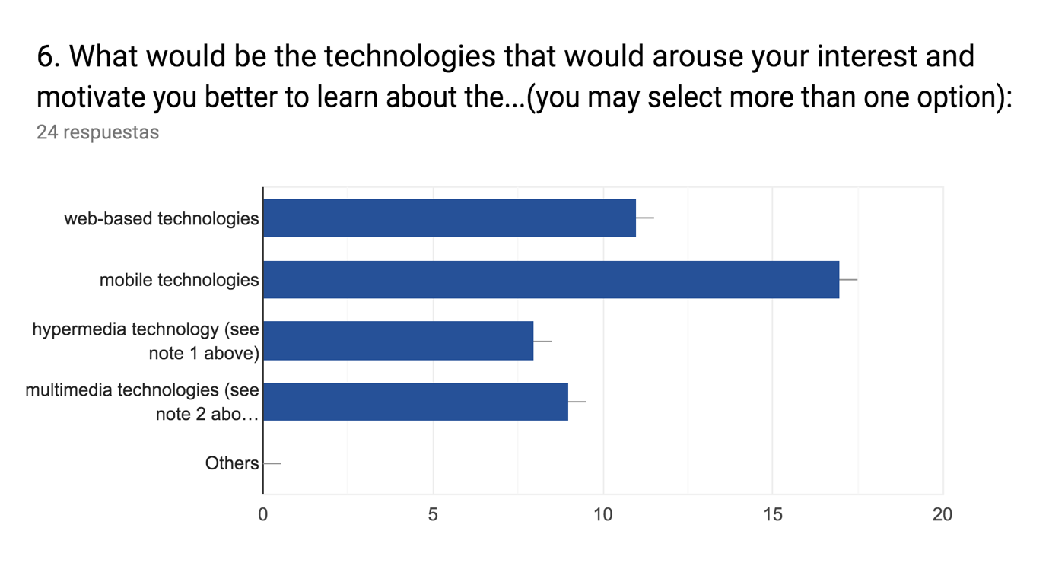

Regarding ***how they would like the provided information to be structured / approached within the materials that the NGEnvironment consortium will prepare for them and include in the project’s Engagement Toolkit*** (Question 7), the majority of the respondents would appreciate *a very structured (concise) information and with provided links for more details* (N = 13; 54,17%), or *sequential information (‘portions’ of information delivered one after the other, provided at different stages in project’s lifetime)* (N = 8, 33,33%), while only reduced percentages of respondents would prefer *complete information, with all details at once* (N = 3, 12,50%) or

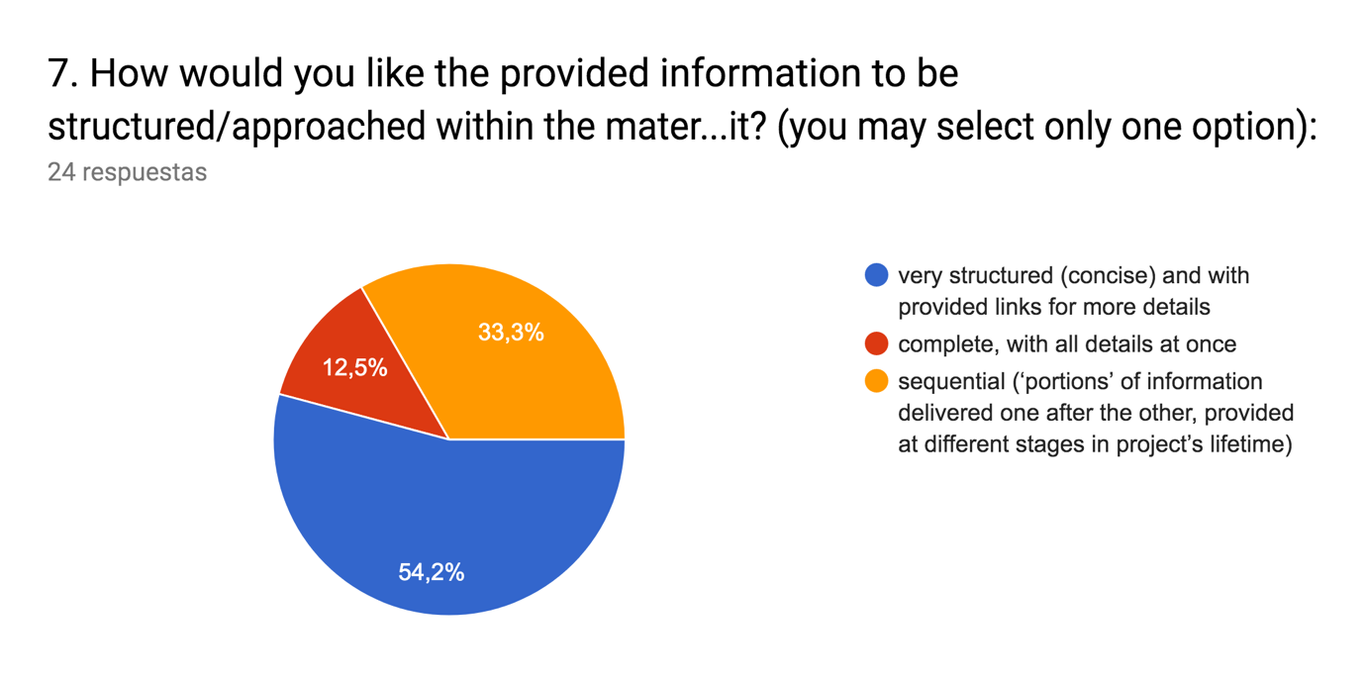

Regarding ***any necessary recommendations for the NGEnvironment consortium regarding the development of contents and materials to be included in the project’s Engagement Toolkit*** (Question 8), we got only few but relevant answers:

* To provide an index.

* Materials should be easy to read, concise and with a nice layout design

* Infographics add really value information and help to read easily.

* WhatsApp is a useful tool for dissemination

1. **Conclusions**

Our conclusions for the present research are:

**The Spanish project target groups** (potential new NGO leaders; existing NGO leaders and staff members; social and green activists.) **are specially interested** in getting information and materials for the field of NGO or business **on** the following issues: **good practices, resources, useful links, incentives and legislation.**

The types of informational materials most acceded by the mentioned groups are: *articles, newsletters, books and magazines*. The same forth types are also preferred when asked about the types of project materials they would like to receive. Therefore, it seems that **the NGEnvironment consortium should focus on the creation of articles, newsletters, books and magazines for the project Engagement Toolkit**, as far as Spaniards are concerned.

With respect to the dissemination and advertising channels that **the NGEnvironment project should use, social media, emails and websites as well as workshops, meetings and conferences** are the ones preferred by Spaniards. The score obtained by the press channels are really low (the highest is for written press: 2,44%), so press media are not relevant for the project dissemination according to the preferences of the surveyed sample group.

**Regarding technologies, the *mobile***(N=17; 37,78%) **and the *web-based*** *(*N=11; 24,44%) **ones are clearly preferred** by the respondents. Likewise, the most impactful support-media for the NGEnvironment Engagement Toolkit would be **the video and the mobile phones.**

At the same time, **the NGEnvironment consortium should provide concise information** since it was preferred over half of the sample (54,17%), or *sequential information* (33,33%), avoiding the dissemination of materials with the *complete information.*

*Lastly, useful recommendations were provided by the respondents, among which would like to stress the use of infographics and WhatsApp as impactful materials and channels.*

***According to the research findings, it seems that the materials and channels already identified by the consortium for the NGEnvironment Engagement Toolkit are appropriate for the Spanish preferences. As an example, audio-visual testimonials, videos, brochures or infographics were preferred or mentioned by the survey sample. Other materials shosen by the respondents (articles, newsletters, etc) will be not included in the Engagement Toolkit but in the dissemination plan, where the main online and face to face channels were also considered (especially social networks, websites and meetings). Therefore, we can conclude that the Spanish targets groups will have their informational needs about the project sufficiently covered.***

