NGEnvironment
IO8 — Policy Paper

Developed by SINERGIE

Foster European Active Citizenship and
Sustainability Through Ecological Thinking by NGOs.

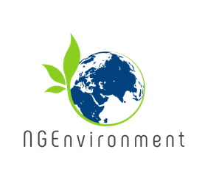
Erasmus+ Programme — Strategic Partnership
AGREEMENT NUMBER
2018-DE02-KA204-005014
Table of Contents
1.0 Executive Summary 3

2.0 Introduction 4
3.0 Background 5
3.1 Analysis 9
3.1.1 The main challenges NGOs are called to face 9
3.1.2 Barriers and opportunities 11
3.2 Policy Options 13
3.2.1 Environmental Governance 13
3.2.2 The role of a participative and engaged civil society in environmental governance 14
3.2.3 The Roles of NGOs 15
3.3 Recommendations 16
3.3.1 High-quality training to ensure that NGOs can effectively respond to the local / regional needs and help achieve the EU 2020 goals, the SDGs of the UN for 2030, the EU Green Deal goals, etc. 16
3.3.2 Supporting the development of the NGO sector to foster sustainability in its 3 axes. 17
3.3.3 Development of a partnership between NGOs and other operating agents / sectors to achieve common framework towards sustainability 18
3.3.4 Next Steps 19
4.0 Conclusion 20

1.0 Executive Summary
In order to sum up all the main findings, best practices and lessons learned during NGEnvironment implementation, a Policy Paper addressed to decision makers has been developed, with the aim of ensuring the relevance of the project, its outreach at a policy level, and the sustainability of its benefits beyond the funding period. The Policy Paper represents a useful resource for peer stakeholders across Europe, and identifies specific recommendations for policy makers.
After an initial presentation of the main goals and motivations for the Paper, the current policy concerning NGOs management and support at an institutional level will be outlined, followed by an analysis of its critical aspects and the need to find new opportunities and solutions. Afterwards, the paper will explore the available alternatives in terms of policy and their implications, together with some criteria to evaluate them. On the ground of the application of those criteria to policy options, it will outline some basic recommendations to be implemented in order to foster the potential of civil society and NGOs in bringing about social action and positive change. The paper will finally identify the future steps policy makers can take to further engage on this process, and finally conclusions will be drawn to sum up the basic recommendations.

2.0 Introduction
The main goal of the Policy Paper is to present and suggest a course of action based on an institutional perspective. Unlike other project’s outputs, which were directly targeted to the primary actors of the NGO sector, the Policy Paper targets a decision-making level and will be distributed among relevant policy stakeholders such as public bodies, government agencies, entities with the ability to support or fund civic action and NGOs.
The Policy Paper gathers the main findings of the project, provides evidence and discusses why a change in NGO policy approach might be relevant – at least in the green and social fields; it also presents the policy options available, the pros and cons of each option, and the impact and value for money resulting from NGO action. The document is based on the feedback provided by specific stakeholders from the non-profit sector, on the occasion of interviews carried out with project Partners or video testimonials released during the lifetime of the project.

3.0 Background

NGOs are increasingly aware of UN’s Sustainable Development Goals (SDGs) and have started to take dedicated action. SDGs were adopted by all United Nations’ member states as a universal call to action to end poverty, protect the planet and ensure that all people will enjoy peace and prosperity by 2030. The mission of environmental NGOs, in particular, aims at pursuing the following goals:
Affordable and clean energy

N.7
Clean water and sanitation

N.6

N.11
Sustainable cities and communities
§
N.12
Responsible consumption and production

N.14
N.13
Climate Action
Life Below Water

N.15
Life on Land

NGOs are also pursuing other objectives, as all SDGs are integrated – that is action in one area will affect the outcome in other areas, too. A long-lasting improvement, in fact, should not only include environmental sustainability, but also deal with social and economic development, and strike a balance among the three. Another inspiring goal NGOs should look at when defining their mission is the “smart, sustainable and inclusive growth” promoted by Europe 2020 strategy.
Since NGEnvironment focuses on European NGOs, it is also important to consider the European Green Deal, i.e. the set of environmental policy initiatives and targets launched by the European Commission in 2019, the most important one being climate neutrality to be reached by 2050. The European Union, in fact, aims at becoming a sustainable, modern and competitive economy where economic growth is not directly linked to the use of resources.

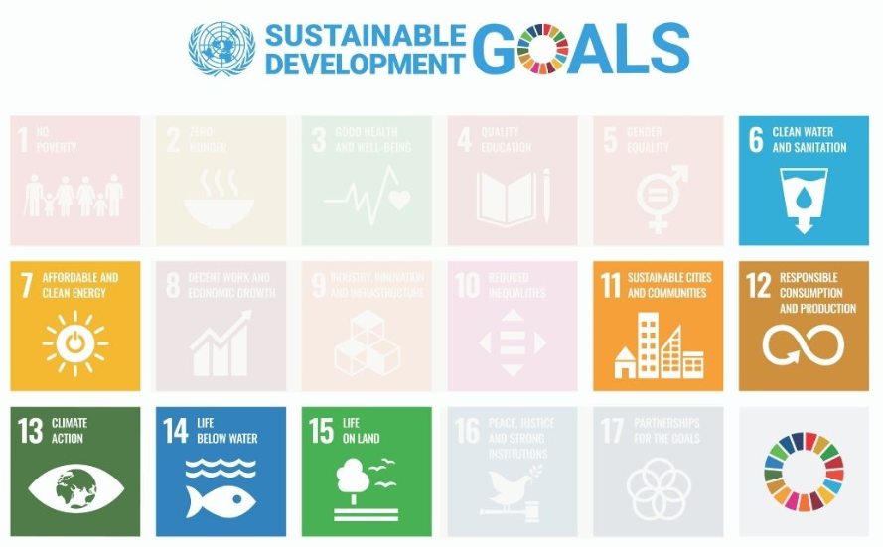
For this reason, an Action Plan was issued with a number of actions in different policy areas:
- Climate neutrality: with the final goal to eliminate GHG emissions by 2050, the intermediate target is reaching at least a 50% (going towards 55%) reduction by 2030.
- Mainstreaming sustainability in all EU policies, such as a sustainable industry, a sustainable and smart mobility, and a sustainable agriculture. The latter action is also included in the Farm to Fork strategy, aimed at creating a greener food system.
- Preserving and protecting biodiversity.
- Promoting a clean, affordable and secure energy system (e.g. through initiatives like the Renovation Wave strategy for the building sector).
- Eliminating pollution for a toxic-free environment.
- Promoting the EU as a global leader in environmental policy, by further strengthening the international policy framework and by collaborating with the member States.
NGOs facilitate the dialogue and communication with citizens and make the general public aware of a number of issues related to development, cooperation, ecological transformation of society, sustainability, protection of the environment, sustainable development of local communities. In fact, participation in NGOs activity and, generally speaking, being aware of the environmental challenges ahead will enable citizens to take conscious decisions in those aspects of their everyday life they have some power on and are responsible for. The role of the non-profit sector is also fundamental to foster cultural transition towards a sustainable lifestyle and approach to production.
NGOs foster interaction between groups of people and engage them around a common goal so that their enthusiasm and motivation are kept at high levels. The non-profit sector gains its strength by connecting with other entities and actors of the civil society that are active on similar projects. It is thus crucial to nourish these kinds of connections and links and create interactions between groups of people working towards the same objective.

The role that NGOs can play for the development of their community is especially evident in two Irish experiences: BADRA (Bath Avenue District Residents Association) and Ballyjamesduff Community Council. The two organisations provide their respective local communities with supporting facilities (e.g. recreational, educational, healthcare and childcare services) in order to address the existing and potential needs of community members. They also participate in local level projects and collaborate with authorities in order to maintain the area and protecting the environment. The representatives of these two associations emphasise the importance of keeping NGO action at a local level, and establishing a stimulating dialogue with the members of the community to make people connect together. They also underlined that NGOs find themselves in a special position, between communities and policy-making level, and are therefore able to create a bridge between the two groups. Consensus towards NGOs is generally high and, for this reason, it is more important than ever to invest in their development and in the creation of passionate and skilled leaders.
NGOs listen to people needs and really work at a local level. The idea of establishing an organisation, in fact, usually stems from the observation of reality within a certain territory, and from the desire to contribute in improving said reality through local development projects. A significant example of this path is represented by Puglia Eco Travel, an experience that was presented to NGOs’ volunteers who participated in NGEnvironment pilot training activities in Italy, as it contributes to environment protection, while promoting tourism on the local territory. From a territorial dimension, an NGO could hopefully become a reality consolidated at a national level and have an impact on the society as a whole, as it means that it succeeded in pursuing its mission. Due to their task in awareness-building and information spreading, NGOs need to be supported on a political level in making their ideas concrete.
Civil society is therefore a critical stakeholder in decision-making processes on environmental issues, and a valuable partner in implementing and monitoring environmental policies at a local, national and global level. Provided that they are equipped with the suitable skills and adequately developed capacities, both CSOs (Civil Society Organisations) and NGOs (Non-Governmental Organisations) can provide technical support to communities and support both environment and development programmes at a local level. They are also in a position to provide policy recommendations to local and national authorities, and to foster smooth communication between policy makers and local actors.

3.1 Analysis

3.1.1 The main challenges NGOs are called to face
Current policies targeting NGOs fail to ease their development and empowerment as policy entities due to a number of reasons: first of all, the excess of bureaucracy – such as in the case of Menalos Social Cooperative in Greece, which was founded with the goal of cleaning forests of the Mainalos mountain from detritus and rotten material, but could not pursue this goal due to bureaucratic constraints from Greek public administration. As declared during the interview carried out in the context of NGEnvironment project, the Cooperative “reinvented” itself and changed its goal, by still continuing to operate in the same Mainalos area: it started by promoting sustainable trips on hiking trails.
Another problem concerns the lack of funds, or the discontinuous provision of funds and donations to NGOs, preventing a smooth management of the projects and activities, because it is not possible to cover unexpected costs and expenses. Sometimes funds can cover only part of the total cost of an activity. Due to the lack of regular funding, it is difficult to provide volunteers / NGO members with regular training programmes keeping them updated on the news of their sector.
The lack of feedback and social support on the part of citizens is also a difficulty preventing the effective implementation of NGOs’ actions. Usually the problem stems from the general indifference of population towards certain topics, as in the case of INGMED Students’ Association – a NGO founded in Romania in a University context, and focusing on waste management, cleaner technology and habitat conservation. Although their message is not always welcomed by the civil society, INGMED members continue to launch initiatives aimed at awareness creation, and most importantly at the promotion of a more sustainable lifestyle as a key solution to environmental problems.
A most challenging problem is undoubtedly the effect of Covid-19 pandemic: due to the current situation, in fact, many projects were postponed or eliminated; moreover, as NGOs are based on human work and interaction, it is difficult to keep connections, organise training and take care of the social structure in a period when direct contact is forbidden. An example of the difficulties non-profit organisations are called to face is represented by PASOS (Platform for Sustainable and Solidarity Activities), an NGO founded in Spain in 2006, with the goal of bringing together multiple projects and entities focusing on environmental issues so that they can empower each other. Due to its synergic and interactive nature, PASOS was extremely challenged by the Covid-19 situation, but still manages to keep high hopes for the future.

3.1.2 Barriers and opportunities
Although participatory processes increased around the EU in recent years, the involvement of civil society in environmental governance remains quite low, even in those cases where it would be highly beneficial. An example is that of Forest School Association in Portugal, an organisation dealing with the promotion of training activities in the woods. Due to the lack of a recognition of the important role that contact with nature plays on children’s pedagogical development and well-being, the experience offered by Forest School does not have the dignity it deserves. It is therefore vital that civil society, first and foremost those groups which could potentially benefit by such an experience (in this case parents), start to acknowledge the existence of non-profit associations like Forest Schools, and the opportunity they represent for society as a whole.
Hinderances can be due to a widespread fear on the part of institutions that NGOs may constitute special interest groups, and that their engagement will lead to policy distortions. On the other hand, civil society involvement can provide substantial advantages to the political discourse thanks to NGO’s experience and technical knowledge on environmental issues. These actors, in fact, represent valid alternatives to public institutions, which are not as specialised nor as engaged as NGOs. They have the role of facilitators of a more inclusive dialogue with the population, by creating awareness among citizens, and they also represent a driver for disseminating information on environmental policies and sustainable lifestyles. By creating spaces for collaboration with the authorities, NGOs can thus become key players in the development and in the implementation of environmental policies.

For an environmental governance to be effective, it is crucial that NGOs cooperate with institutions and provide their experience-based input in the decision-making process. This can translate in taking independent action, or work in cooperation with governmental actors: e.g. by conducting research, organising environmental training and education activities, raising citizens’ awareness on urgent environmental problems and looking for possible solutions. The NGO Moam, founded in 1999 in Malta, provides an interesting example of how and to what extent organisations can impact on the decisions taken on a policy level. Moam, in fact, aims at converting traditional farming practices to organic agriculture by fostering the use of natural products to grow crops. At the beginning of its journey, the members of this NGO pushed local authorities to adopt EU legislation on organic products and, as soon as MOAM started to establish itself as a recognised entity in the country, they began to launch educational initiatives targeted to schools and kindergartens in order to teach kids where the food comes from. By combining policy making with an educational impact, the NGO succeeded in pursuing its goals.

3.2 Policy Options

3.2.1 Environmental Governance
When talking about policy making in the field on environment protection, we are usually referring to environmental governance. This specific type of governance includes all the institutions, policies, rules and practices fostering and mediating the interaction between the environment on the one hand, and government, the private sector and civil society (including NGOs) on the other hand. Civil society, in particular, plays an important role in policymaking in the field of environmental governance, and its function has been officially accepted and recognised at an international level. It is important that NGOs promote even further society’s engagement in environmental policy, by promoting a number of initiatives target to different groups. It is the case of NABU – Senne Nature Information Centre in the Prinzenpalais – a German NGO and an information centre specialised in nature conservation and protection of the surrounding landscape. NABU organises touristic excursion and training programmes to be carried out in schools. In particular, it launched two types of training courses: the first one had a more traditional approach to natural education programmes, while the second one concerned sustainable development and aimed at sensitizing young students towards sustainability best practices (e.g. reduction of plastic, fair trade, responsible use of drinking water, etc.).
An effective environmental governance ensures the participation of all actors and their collaboration towards a common goal: environmentally sustainable development. This kind of governance represents an alternative to conventional top-down practices of policy making, because it involves both citizens and CSOs in identifying, creating and monitoring environment and sustainable development policies. This means that all stakeholders who are affected, in a way or another, by these policies should be able to participate in their initial definition, implementation and monitoring. In the cases dealt with by NGEnvironment, citizens and communities are invited to express their concerns and points of view on environmental policies affecting them and, hopefully, will be granted the possibility to contribute in the management of natural public goods and the environmental commons.

3.2.2 The role of a participative and engaged civil society in environmental governance
Civil society has become a critical stakeholder in environmental decision-making processes and an important partner in implementing and assessing environmental policies at a local, national and global level. When their capacities are adequately developed, CSOs and NGOs can provide technical assistance to communities and support the development of specific programmes, and provide policy recommendations to governments, facilitating communication between institutions and local actors.
Civil society involves a wide range of actors, including individuals, religious and academic institutions, issue-focused groups like non-profit or non-governmental organisations. It plays a key role in filling the gap between population and the policy level, as far as information and exchange are concerned. In fact, an engaged civil society collects and disseminates relevant information on environmental governance and related topics, fosters policy development and implementation through continuous assessment and monitoring, and makes sure that the needs of those actors who will be affected by environmental policies are considered in the decision-making process. NGOs, in particular, enable networking among different stakeholders so that they can address issues in a collaborative way and emphasise the importance of acquiring the necessary skills and mindset for a sustainable management of natural resources.
Besides advisory and support roles, civil society organisations can also take on a more direct role in environmental management and governance, for example through representation in multi-stakeholder governance platforms. The involvement of NGOs and the impact they can ensure vary according to the type and the size of the organisation but, generally speaking, it can cover local, regional, national and/or international level.

3.2.3 The Roles of NGOs
NGOs can take on many different functions in environmental governance. For example:
- Mobilize public opinion by increasing their outreach, spreading information, building awareness and engaging stakeholders.
- Give voice to those civil interests that are usually under-represented at a policy making level, for example by voicing the needs of marginalised groups of individuals through campaigning, educational projects and participation in public debates.
- Foster constructive dialogue between civil society and the institutions: this can be done either in a bottom up way (i.e. from grassroots level to policy making) and a top down one (i.e. from the government to the people).
- Provide fresh ideas and experience-backed recommendations to policy makers and politicians, thereby facilitating negotiations and bringing common concerns to the policy level.
- Respond to societal challenges and even shocks faster than political institutions.
- Participate in operational activities, in order to support the implementation and management of environmental projects launched by the government.
- Monitor of negotiate efforts on a number of political agreements.
- Legitimize decision-making mechanisms, thus making policy choices taken by international organisations more acceptable by involved actors.
- Empowering citizens and supporting their initiatives at a local level, as they usually provide concrete benefits to the society as a whole.

3.3 Recommendations

3.3.1 High-quality training to ensure that NGOs can effectively respond to the local / regional needs and help achieve the EU 2020 goals, the SDGs of the UN for 2030, the EU Green Deal goals, etc.
High-quality training is crucial to build up the role of the NGO leader. According to the description provided in NGEnvironment project, he/she is able to pursue both the goal of the NGO itself and foster the personal development of its members, so that new leaders can emerge. It is therefore important that NGO leaders master the most adequate skills which, following the improvements brought about by the digital revolution, can be summarised as follows:
- Flexibility and adaptability to ever changing circumstances.
- Creativity, i.e. the ability of doing more with less resources.
- Readiness to update their own skills through a lifelong learning approach.
The role of an NGO leader is unique because it includes both his/her personal attitudes (such as charisma) and a number of soft skills that can be achieved thanks to a specific training. For example: self-awareness, the capacity to build relations, empathy, creative and critical thinking, effective communication, decision making, problem solving, etc. We can define him/her “smart leader” for at least two reasons: first of all, because his/her role goes beyond the realm of traditional business and market logic; secondly, because he/she is able to cope with a number of different situations, from the management of volunteers’ activities, to the capacity of building effective relations with policy makers and economic institutions.

3.3.2 Supporting the development of the NGO sector to foster sustainability in its 3 axes.
It is important that decision makers support NGOs in facilitating cohesion among local communities, according to the principles of equity, solidarity and collaboration. The last one, collaboration, is especially important to raise concern around topics of a general interest, such as environmental protection and the need to see the environment as the most important common good benefitting all citizens. Furthermore, policy makers should also foster the development of territories at a local level, which needs to be targeted towards the common goal of the Community – i.e. its long-lasting and sustainable development. It is an aim that can be pursued by focusing on the three dimensions of sustainability, namely: social, economic and environmental sustainability. This should be the shared objective of engaged local communities, who are therefore invited to act in a domain of openness, contamination and cross-cultural interference.
The non-profit sector should also be able to encourage the cultural transition towards sustainability and sustainable development in enterprises. This implies a complete revision of production models for companies, but also a cultural shift in the daily lives of normal citizens.
For an NGO to become consolidated in a certain country or context, it is important to bring together similar entities and projects that share some likelihood, by creating and strengthening connections between them. The idea is that each NGO can be empowered in carrying out its main activities, but also in finding common interest.

3.3.3 Development of a partnership between NGOs and other operating agents / sectors to achieve common framework towards sustainability
NGOs are the pillars of our society, in the sense that they channel and represent the actual needs of society, in all those cases where the government fails to meet them by not providing citizens with the right support.
NGOs also play an important role in fostering social impact, and in facilitating a transparent and collaborative dialogue between citizens on the one hand and local / national authority or decision makers on the other hand. Thanks to this, they can reach out to policy makers at a public level to foster policy change.
Finding a common operating ground with other policy entities is crucial for NGOs to gain practical and financial support from other organisations, such as Universities, schools, companies, local authorities, etc.

3.3.4 Next Steps
Policy makers should adopt the necessary measures to strengthen the skills of NGOS’ members, in particular as far as environmental knowledge is concerned. To this aim, specific actions have been proposed by the NGEnvironment project through specific training, in order to develop the internal capacities of the staff in areas like pedagogy, leadership, business management and communication. It is our hope that policy makers will draw inspiration from the project and implement systematic training and capacity-building activities targeted at the non-profit sector.
Policy makers should also invite NGOs, as representatives of the civil society, to participate in an informed way in the definition of environmental policies. In this way, active participation of citizens in the decision-making process will be considered a grounding element of transparent representation at a policy level and, in addition, institutions will be required to consider their point of view from a multi-stakeholder perspective.
NGEnvironment project is in line with these objectives, as it promotes coordination and foster the exchange between NGOs and policy stakeholders, with the aim to strengthen the influence of civil society, and invite it in engaging with the authorities in tasks and activities concerning environmental governance.

4.0 Conclusion
From all the aspects considered in the present policy paper, it is possible to draw some conclusions, which will be summarised in the following paragraphs.
First of all, when NGOs’ activity is coordinated and volunteers are well trained, results will be long-lasting and have a greater impact on society through environmental decision-making. To this purpose, multi-stakeholder partnerships and platforms are necessary to improve environmental governance in the long run, as they bring together different points of view and expertise, and create consensus among stakeholders. However, in order for NGOs’ activity to be successful, this should be combined with concrete efforts on a policy-making level, which will also increase the impact on public participation and engagement.
The creation of networks of environmental NGOs and like-minded organisations working towards a common goal contributes to expand the impact and the outreach of civil society in environmental governance, thus embracing their ability to influence policy-making, foster change and being considered by environmental processes. NGOs have a major role in disseminating environment-related information through awareness building campaigns and training activities targeted at different groups of stakeholders, as this will further increase public participation. It is therefore crucial for NGOs’ members to master social media and information technology, as these tools are essential to ensure a wide outreach and create an effective communication to raise public awareness and spread knowledge. Online “public spaces” became even more prominent due to the effects of Covid-19 pandemic, which is obliging people to interrupt or reduce physical social contacts.

Enhancing the skills and capabilities of NGOs will also make the principles of the Aarhus Convention more viable. The Convention, adopted in 1998, grants the following rights to the public sector: access to environmental information, public participation in environmental decision-making, access to justice in case of governmental disputes on environment-related topics. These three rights entail the possibility for citizens to become active participants and contributors in environmental decision-making.
As this paper strived to prove, the role of NGOs has finally started to be publicly recognised, in particular in those cases when the mission of the organisation manages to meet one or more of the objectives set out by international entities. As already mentioned, environmental NGOs are crucial for the achievement of some of UN’s Sustainable Development Goals, and also in order to meet the requirements established by the EU Green Deal: first and foremost, making the European Union the first climate neutral continent by 2050, but also promoting a sustainable approach in a number of different policies (from agriculture to mobility), and contributing towards the creation of a cleaner and greener environment for future generations.

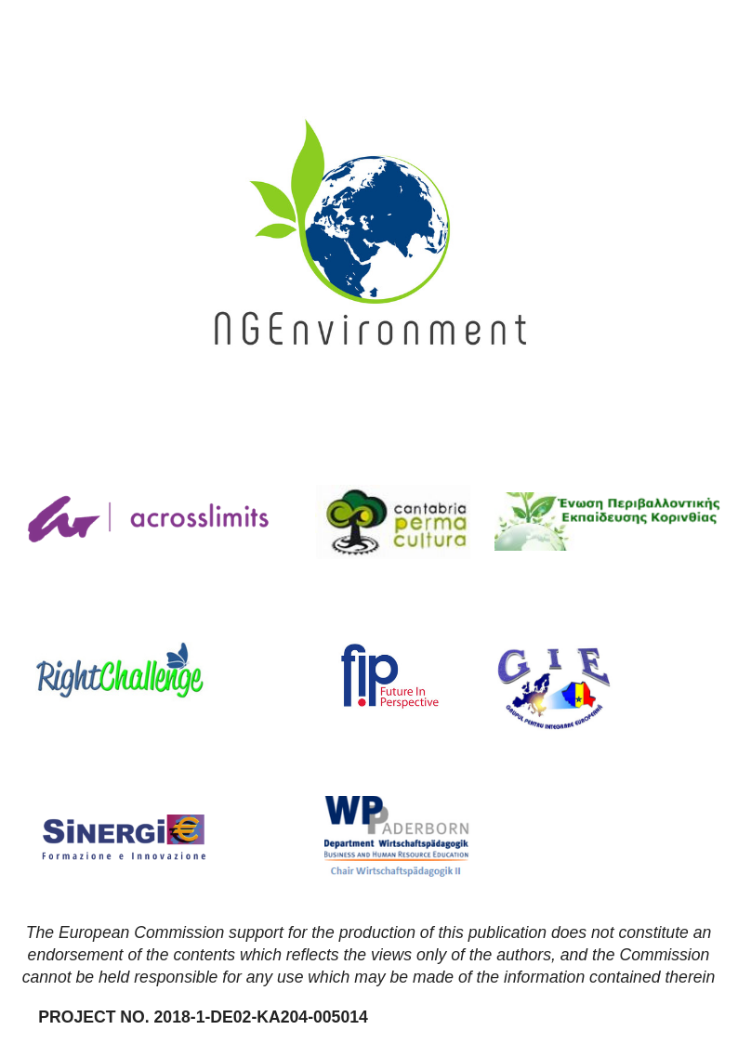

Images

- “Change for Change” - Katt Yukawa
- "Fist” - Branimir Balogović
- "Smoky morning in Cascades” - Sergei Akulich
- Untitled - Anna Earl
- Untitled - Priscilla Du Preez
- "The Australian House of Representatives at the Australian Parliament” - Aditya Joshi
- “Group of business workers standing with hands together doing symbol at the office” - krakenimages
- “Team building at RGB Parkour Tour” – Shane Rounce
- “Woman sitting at table” – Campaign Creators
- “2018 he we come!” – Miguel Bruna
- “Woman holding green leafed seedling” - Nikola Jovanovic

