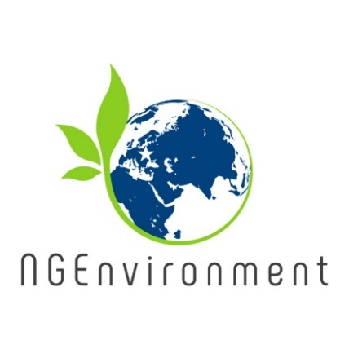

**What NGEnvironment is about?**

NGEnvironment arises as a relevant contribute for the EU horizontal priorities of improving relevant and high-level basic and transversal competences of EU citizens, in the scope of adult education and under the perspective of lifelong learning, as it aims at capacitate new leaders for change engagement, improving entrepreneurial, foreign language and digital skills and fostering employability, socio-educational and professional development, through NGO action.

By capacitating NGO leaders, NGEnvironment will contribute to improve/extend the supply of high-quality learning opportunities tailored to the needs of low-qualified adults so they acquire literacy and entrepreneurship skills, with the recognition of such skills.

NGEnvironment will specifically be tailored for adult audiences, fostering social cohesion, boosting talent and taking their specific needs/concerns into account, and delivering novel learning approaches through a holistic, participative, motivational pedagogical process that will ultimately result in the development of many key competences with a long-term effect on European active citizenship for sustainability.

Social inclusion will be achieved as NGEnvironment seeks to train new NGO leaders providing equal learning opportunities for all, despite their gender, religion, cultural background, age, etc. The project will foster social integration by creating jobs for socially segregated or low-skilled people.

The main general envisaged objectives of the NGEnvironment are:

● To support the development of a new generation of NGO leaders;

● To provide relevant support to existing and future NGO leaders;

● To be at the forefront of strategies and programmes for leadership development that incorporates best practices and current experience/expertise, from a multitude of countries and cultures across Europe (south, north and central).

**What NGEnvironment will achieve?**

● An initial Research Report to set the state-of-the-art.

● Two Training Packages, for NGO mentors and new NGO leaders.

● An online Platform and Observatory (a repository of outputs, best practices, role models).

● An Engagement Toolkit assuring broad outreach of the project and motivating participation.

● Instructive videos with NGOs best practices.

● A ‘Survival Guide for NGO Founding and Funding’.

● A Layman Report explaining the whole projects’ rationale, objectives, main conclusions and resulting case studies.

● A Paper Policy stating why a change of policy approach towards NGO support might be relevant.

**Newsletter - Issue 1**



**What already happened?**



The project has officially started on 1st of September 2018.

Soon after, the project consortium has met for the kick of meeting. The meeting took place between 5th and 7th of November 2018, in Lousada (Portugal) being hosted by the coordinating institution, Right Challenge.

The meeting had the purpose to allow partners to know each other, to talk about the project objectives and activities and to start planning the first working tasks for all partners.

All foreseen project results have been approached and discussed in detail, as well as administrative and financial issues, dissemination & exploitation aspects, evaluation and reporting procedures.

**How to get connected with NGEnvironment:**

Visit our website:

http://eduproject.eu/NGEnvironment

or contact the partner in your home country!

**Coming next…**

* Finding a common approach regarding the NGOs and their needs, starting from the realities in each partner country.
* Performing a research exercise to inform the training framework and learning outcomes matrix, creating thus the foundation for the induction to Pedagogy for NGO staff.
* Starting working in core team on the curriculum for the training package for social and green NGO leadership.
* Performing dissemination actions.

