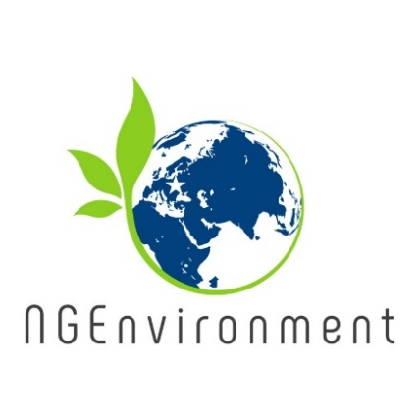

**First NGEnvironment results and outputs:**

1. Research Reports
2. Induction to Pedagogy for NGO staffs
3. Training package for social and green NGO leadership

The partners performed a brief national desk research regarding *“How important is the NGO sector in your country?”*, focusing on the following aspects:

*• What kind of importance do the NGO’s have in the community, both at local and national level?*

*• Do NGO’s play an important role in the communities? How? In what areas?*

*• Does the sector employ many people?*

The national research reports have emphasized that there is diversity across the partner countries in how the NGO is defined and reflected in the own legislation, which are the legal procedures to found such an organisation and what kind of specific activities the NGOs provide to their local communities.

A common feature of the NGOs is that the majority of them are active in supporting disadvantaged groups and providing customised services to them, having thus a crucial role for society. Promoting social causes is another direction in which NGOs make their presence felt.

The creation of NGOs is on a positive trend in all partner countries and the green NGOs are gaining visibility nowadays as ‘going green’ is more and more present in our lives while we are facing population growth and resource consumption, climate change and global warming, habitat conversion and urbanisation, invasive alien species, over-exploitation of natural resources and environmental degradation, which have become major concerns that require efficient solutions.

The emergence and development of NGOs is a present proof of participatory democracy.

The findings form this research have been used as a starting point in designing the next project outputs, namely (a) the induction training for NGO staffs and (b) the training package for social and green NGO leadership. The training follows to be achieved in February 2020, hosted by our Italian partner Sinergie, in Reggio Emilia.

**Overview of NGEnvironment Induction to Pedagogy for NGO staff**

During this induction training, which will mostly be in a format of e-learning existing NGO staff members will improve their pedagogical skills regarding communication, openness to answer questions, pedagogical methods, risk management and conflict resolution, among others.

NGEnvironment proposes an immersion model, where new NGO leaders/staff members can develop their entrepreneurship ideas in a real working environment. Being immersed in this environment will support them in: (1) gaining an understanding of the many facets and challenges of running an NGO; (2) the multiple skill-sets required; (3) the different roles that NGO leaders need to play on a daily basis.

Taking part in the immersion programme will elucidate potential new leaders in many aspects of managing an NGO, and this real-life experience will boost the understanding and perception these new leaders will have when attended the training course.

**Newsletter - Issue 2**



**What already happened?**

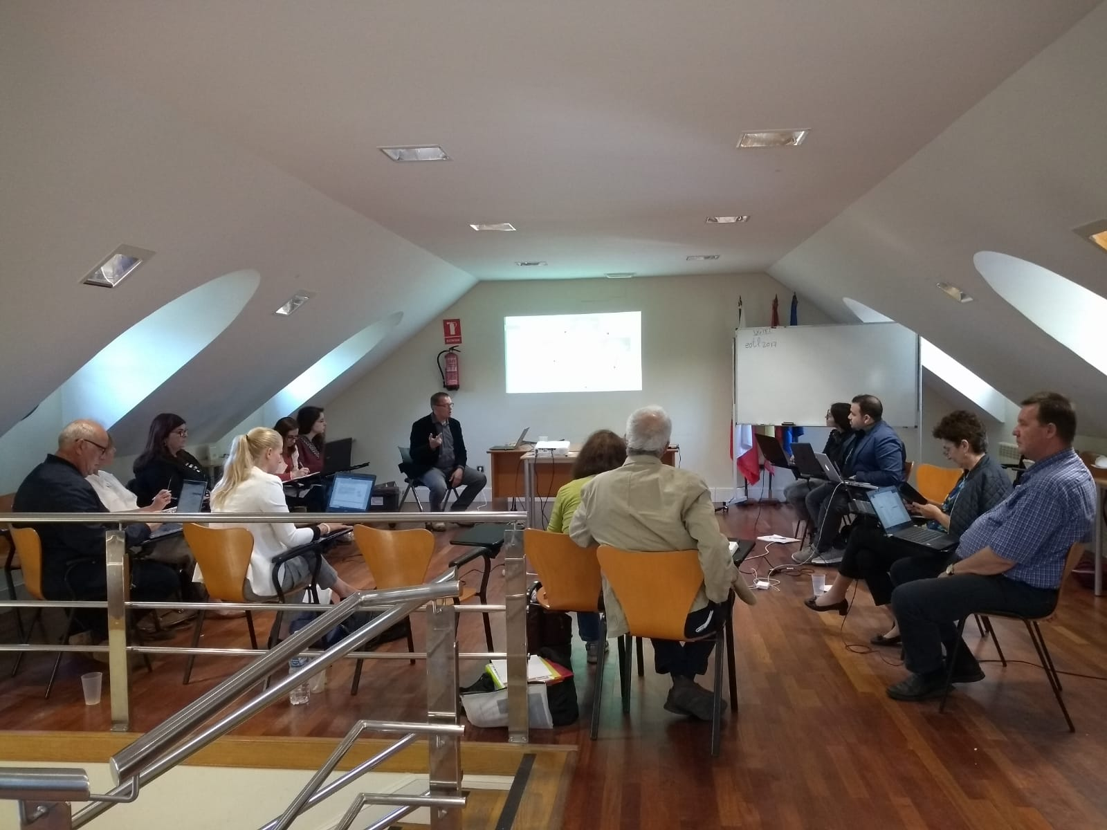

The 2nd project meeting was held on 22nd and 23rd of May 2019, In Santander (Spain). It was organised by the Spanish partner Asociacion Cultural Y Medioambiental Permacultura Cantabria.

The purpose of the meeting was to analyse the project achievements so far and to decide the next tasks and activities. More specifically, the partners approached the induction training for NGO staffs and the training package for social and green NGO leadership in terms of content (what modules to be developed) and organisation (how many participants per country and what profile), but also the project online platform and observatory, the Engagement Toolkit for stakeholders and financial issues regarding the reporting on project’s activities.

**How to get connected with NGEnvironment:**

Visit our website:

http://eduproject.eu/NGEnvironment

or contact the partner in your home country!

**Coming next…**

* The project partners will implement a bespoke, modular leadership training course that specifically addresses the development of management and entrepreneurial skills for the NGO sector.
* The new training course will have 5 days of face-to-face learning actions that will be complemented with the online resources available in the project’s website, and will include normal leadership and entrepreneurship development modules:

(1) introducing leadership;

(2) introducing green and social entrepreneurship; (3) creative thinking, initiative, self-confidence;

(4) idea generation and evaluation;

(5) testing and prototyping the idea;

(6) communications and outreach;

(7) funding mechanisms.

More about this course in Newsletter 3!

