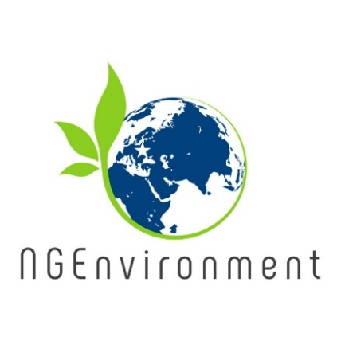

**Transnational Training Event in Reggio Emilia (Italy)**

A Learning/Teaching/Training Activity (LTTA) took place between 2nd and 7th of February 2020, in Reggio Emilia (Italy). The event was hosted by SINERGIE. The training was addressed to adult trainers, entrepreneurs and adults interested in social and green initiatives and was attended by 31 participants. Participants had the opportunity to develop their knowledge and skills and to boost their ideas and talent directly with the training received, but also indirectly through the international experience, IT usage, testing and validation, immersion programme and informal discussions with other participants.

The training added value to the global meaning of the project, as it tackled two aspects that are fundamental for embedding sustainability and societal values in the collective behaviour: 1) it provided potential or existing NGO leaders from 8 countries (Germany, Italy, Romania, Malta, Portugal, Ireland, Greece and Spain) with more specific skills and knowledge related to environmental, green and social entrepreneurship, and sustainability as a whole; 2) supported the NGO leaders to become more efficient in sharing and applying the knowledge gained and reflecting on practices in their NGOs.

The international group of learners who attended the LTTA were able to exchange experiences, debate cultural context and thus promote best practice, social awareness and integration. Providing the trainees with an international multicultural experience was enriching for those EU citizens in general, but also from the perspective of how they lead and manage their NGOs, with a highly relevant added-value. The training included 2 parts: *“Induction to Pedagogy for NGO staff”* and *“Training package for social and green NGO leadership”*. The training agenda covered 12 training modules, inter-woven with practical exercises, case study presentations, group discussions, sharing experiences, as well as other activities and assessment. Participant feedback was very positive, expressing the value of the training for their personal development and equally for the benefit of their organisations and the future work they will implement.

**Overview of Training package for social and green NGO leadership**

This bespoke, modular leadership training course specifically addresses the development of management and entrepreneurial skills for the NGO sector. It was developed by the project consortium to support the acquisition of key high-value competences necessary for establishing green and social civic action.

The training course is designed for 5 days of face-to-face learning that are complemented with the online resources available through the project’s website.

The training course comprises the following modules: 1. Introducing Leadership; 2. Introduction to Green and Social Entrepreneurship; 3. Creative Thinking; 4. Idea Generation; 5. Testing and prototyping; 6. Communication and Outreach; 7. Funding Mechanisms.

**Newsletter - Issue 3**



**What has already happened?**

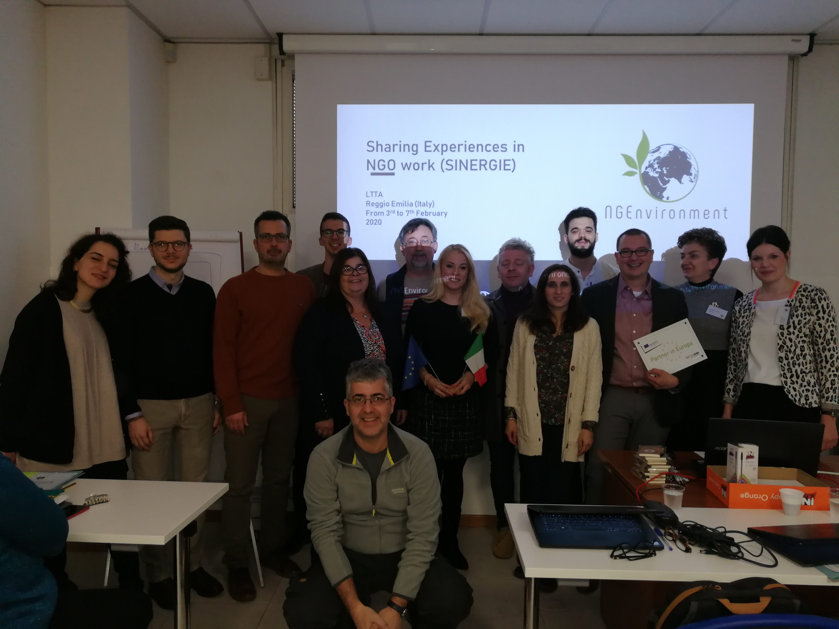

The third project meeting was held on 3rd February 2020, in Reggio Emilia (Italy), hosted by the Italian partner SINERGIE. The purpose of the meeting was to analyse the status of the project (including the recently completed LTTA) and to decide the next tasks and activities. An important topic covered was the preparation of the Interim Report by 30.03.2020. Also, the partners decided how they will complete their tasks in relation to finalising the Engagement Toolkit, translating the courses *“Induction to Pedagogy for NGO staff”* and *“Training package for social and green NGO leadership”* into all partner languages and producing a Policy Report for policy makers and a Layman Report for non-specialist audiences.

**How to get connected with NGEnvironment:**

Visit our website:

http://eduproject.eu/NGEnvironment

or contact the partner organisation in your country!

**Coming next…**

* Each partner institution will organise and deliver the training course “*Induction to Pedagogy for NGO staff”* with 10 future NGO leaders in their country, by November 2020;
* Each partner institution will organise and deliver the training course “*Training package for social and green NGO leadership*” with 20 NGO new leaders or existing staff members, in their country, by November 2020;
* The project consortium will elaborate a Policy Report for policy makers and a Layman Report for non-specialist audiences.

In long-term, the project consortium will:

* develop a Policy Report - a research piece focusing on a specific policy issue that provides clear recommendations for policy makers;
* prepare a Layman's report targeted at a non-specialist audience and serving to inform decision makers and non-technical parties of the project objectives and results.
* organise Multiplier Events to disseminate the project results and share its outcomes in each partner country, with 30 participants, by the end of the project (August 2021).

More about this course in Newsletter 4!

