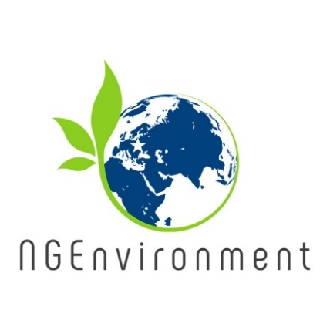

**Overview of the last intellectual outcomes**

**(a) Training package for social and green NGO leadership**

This training course has been successfully implemented in the period August to November 2020, online or face-to-face (according to local pandemic restrictions), in all partner countries. Participants - adult new NGO leaders – were supported to develop management and entrepreneurial skills for the NGO sector, key high-value competences necessary for the establishing of green and social civic action.

This leadership-training course consisted of 7 modules, namely: (1) Introducing leadership in NGOs; (2) Introducing green and social entrepreneurship in NGOs; (3) Creative thinking, initiative and self-confidence; (4) Idea generation and evaluation; (5) Testing and prototyping the NGO idea; (6) Communications and outreach; (7) Funding mechanisms.

The course delivery made use of all developed resources: lesson plans, PowerPoint presentations, interactive exercises in H5P, links for further reading.

The feedback we got from participants was positive, emphasizing on the practical value of the course content and of the skills the trainees have acquired.

**(b) Survival guide for NGO Founding and Funding**

This output specifically provides aid to citizens willing to create their own NGOs or to take part of an existing one in an educated way. It consists of a step-by-step guide explaining all legal and practical requirements needed to found and manage an NGO that has no parallel in the partners’ countries. It also suggests funding mechanisms and provide important ‘surviving’ tips provided from experienced leaders. A specific version of the “Survival Guide for NGO Founding and Funding” has been developed for every project partner country (Germany, Portugal, Romania, Malta, Greece, Italy, Ireland and Spain), adapted to their legal requirements, and they provide practical information and links to find more information.

**Newsletter - Issue 4**

**(c) Policy paper**

The Policy Paper sums up all the main findings, best practices and lessons learned during NGEnvironment implementation. It is addressed to decision makers, with the aim of ensuring the relevance of the project, its outreach at a policy level, and the sustainability of its benefits beyond the funding period. The NGEnvironment Policy Paper represents a useful resource for peer stakeholders across Europe, and identifies specific recommendations for policy makers (public bodies, government agencies, entities with the ability to support or fund civic action and NGOs).

**(d) Layman’s Report**

The Layman’s Report it is addressed to large public. It explains the whole projects’ rationale, objectives, main conclusions and resulting case studies. In simple words, it describes the existing context, the project and the solutions provided by NGEnvironment, the beneficiaries and the benefits for them.



**Final Conference**



The project Final Conference was held online, via Zoom, on 7th and 8th of July 2021. Participants were representatives of large national and international NGOs, as well as those from NGOs working in the fields of Environment and Social work.

All project outcomes have been showcased and discussed, namely:

* IO1: Summary Research Report
* IO2: Induction to Pedagogy for NGO staff
* IO3: Training package for social and green NGO leadership
* IO4: Online platform and observatory
* IO5: Engagement toolkit
* IO6: Audio-visual instructive package
* IO7: Survival guide for NGO Founding and Funding
* IO8: Policy Paper
* IO9: Layman’s Report

**How to stay connected with NGEnvironment:**

Visit our website:

http://eduproject.eu/NGEnvironment

or contact the partner organisation in your country!

**Please note: all project outcomes are freely accessible on our project website!**

**Towards the end of the project…**

* As the project approaches its end (at 31/08/2021), the consortium implements the last foreseen activities and gives a final touch to its outcomes.
* Thus, all partners have implemented in their countries Multiplier Events, that are large dissemination seminars where organisations partner in the project have presented the NGEnvironment outcomes and explained participants how these outcomes have to be used for maximum impact and valorisation. The participants were representatives of the NGO sector and potential new NGO leaders who highly appreciated the NGEnvironment suite of pedagogic resources, the NGO role models and best practices meant to motivate and engage those working in the NGO sector.
* Another important activity currently taking place in all partner organisations is the preparation of the final report – a detailed description of all project activities, achievements and supporting documentation and information.

